JUST REDUCED $$$$$
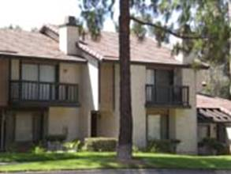

Dear [First Name],

This is from Management One. We have just reduced the price on one of the homes you inquired about from $ to $ per month.

This is an annual savings of ($ ) that you can use for Xmas, the kids or yourself.

If you haven’t seen it yet please drive by the property on your way to work or on your way home. If you have seen it and you would like to put in an application please e-mail me at L1mv@mgtone.com or Call me at 951-924-4315.

