Copyright © 2022 Management One Licensed Operating Systems, LLC. All rights reserved.

Management One Licensed Operating Systems
Knowledge Based Manual
Maintenance Manual
2022
Contents
Table of Contents 4
Introduction 4
Property Inspector Job Flow Visualized 5
Property Inspector Job Flow Chart 5
Components Of Maintenance 6
Task Priority When Coming In From The Field 7
Walk-Through Inspections (Rehab Process Schedule) 8
Rehab Process in-between Residents 9
Rehab Maintenance Checklist 10
Rehab Maintenance Checklist Form 11
First Walk-Through (Vacant Property, Resident, Or Owner Move Out) 12
Video And Photo Documentation 13
Completing Inspections 14
First Walk Through (Owner Move-Out) 17
Final Walk-Through Inspection (See Video For Process) 19
Monthly Exterior Inspection (See Video For Process) 21
Annual Inspections (See Video For Process) 23
Move-Out Inspections (See Video For Process) 25
Move-In Inspections (See Video for Process) 26
Installing For Rent Yard Signs 27
Equipment 28
Job Estimates 30
Notices 31
Vehicle Maintenance 32
Maintenance Service Record 32
Repairs 33
Time Busters For The Property Inspector 34
Recommendations To Owners 35
Property Inspector Processes 37
How to Create a New Job Estimate 39
How to Create a New Job Estimate - Video 39
FAQ- Frequently Asked Maintenance Questions and Answers 40
Quick Reference Flip Chart 40
PI Stadium speeches 41
PI Stadium speech for new owners 41
Stadium Speech for Owner- Email 42
FAQ 43
Keyboard System 44
Keyboard Color Code 44
Color Categories Explained 45
Key Board Statuses & Rental Categories 46
Additional Tags 46
M1 Rehab Algorithm "For Rent" Inventory Tool 48
M1 Rehab Algorithm "For Rent" utilizing the Internal Leasing Report (ILR) 49
M1 Rehab Algorithm "For Rent" utilizing the Resident Move In Ledger (RML) 50
Key Board Protocol 50
One Touch System 52
One Touch System Outlined 52
Contributing Factors that Lead to feeling Overwhelmed 53
Training Tutorials 54
The First 100 Days for Property Inspector / Customer Service 54
The First 100 Days for Property Inspector - Customer Service 54
Testing 55
How to Create a New Job Estimate & Converting to Work Orders 56
New Job Estimate from Command Center 56
Creating a New Job Estimate 57
Transferring the Job Estimate to Work Order(s) 58
How to Create a New Work Order 61
New Work Order from Command Center 61
Creating and Issuing a New Work Order 62
Route Management 64
Access Route Management 64
Creating a Route List 65
Editing your Route 66
Annual Inspections 68
Accessing Annual Inspection Report on Tablet 68
Create a New Annual Report 69
Filling out an Annual Report and adding Pictures during a Walk-through 70
Resident Signature for Annual Inspection 71
Finalizing an Annual Report 72
Sending an Annual Report to the Owner 76
Property Inspector Van Set Up 78
Shelf to Hold Spike 78
"Ask Us" Ryder Tray 79
"Already Rented" Ryder Tray 80
Sign Stand Box 81
Key Machine Box Stand 82
Sign Post Cubbie 83
Spare Parts Tray 84
Peg Board 85
Drill & Bit 86
Passenger Seat Desk Setup 87
Printer and Keyboard Set up 88
Training Process Videos 88
Maintenance Division Work Station 88
Video - Maintenance Division Work Station 89
Tablet Menu Overview 90
Tablet Menu Overview- Video 90
(PCR) Property Condition Report 91
Property Condition Report - Video 91
(FWT) First Walk Through Rehab Inspection Overview Process 92
FWT Inspection Process - Video 92
(FWT) How to Input Data for the First Walk Through in the M1 Solutions Software 93
How to Complete a FWT Rehab Inspection - Video 93
(FINAL) Final Walk Through Rehab Inspection Overview Process 94
FINAL Walk Through - Inspection Process - Video 94
(FINAL) How to Input Data for the Final Walk Through in the M1 Solutions Software 95
How to Complete a Rehab FINAL Inspection - Video 95
(RMO) Resident Move-out Inspection Overview Process 96
Move out Inspection Process - Video 96
(RMI) Resident Move-In Inspection Overview Process 97
Move In Inspection Process - Video 97
(RMI / RMO) How to Input Data for a Move-in / Move-out Inspection 98
How to Complete a Move-in or Move-out Inspection - Video 98
Move-in & Move-out Inspections 99
Inspection Webinar Move-in and Move-out Video 99
Exterior Inspection Overview Process 100
Exterior Inspection Process - Video 100
Exterior Inspection & Violation History Overview 101
Exterior Inspection & Violation History Overview - Video 101
Exterior Inspection Tablet Overview 102
Exterior Overview - Video 102
Annual Inspection Overview Process 103
Annual Inspection Process - Video 103
Annual Inspection Tablet Overview 104
Annual Inspection Overview - Video 104
How to Input Data for the ANNUAL Inspection in the M1 Solutions Software 105
Annual Rehab Inspection - Video 105
The Property Inspector Van & Its Components 106
Video - PI Van and Its Components 106
Van Supply List - Excel 107
How to Install a Premier Sign Post from Lowen Sign Company 108
How to Install a Sign Post Video 108
Work Order Management 109
Work Order Management - Video 109
How to Create a New Work Order 110
How to Create a New Work Order - Video 110
How to Create a New Job Estimate 111
How to Create a New Job Estimate - Video 111
How to Transfer the Job Estimate to Work Order 112
How to Transfer the Job Estimate to Work Order - Video 112
How to Review the Resident Move-in Ledger 113
How to Review the Resident Move-in Ledger- Video 113
Yard Signs in the Property Inspector's Van 114
Video - How to Set up Yard Signs in the Property Inspector's Van 114

Table of Contents

Introduction
In addition to leasing properties, The Company accepts the responsibility of monitoring the condition of the property before, during, and after a resident moves in. The Property Owner relies on the Property Inspector for recommendations for 1) general capital improvements, for 2) general maintenance to keep the property in good condition while occupied and 3) to provide expertise in preparing the property for market when it is vacant. All of these recommendations are focused on securing the highest possible rent based on current market conditions.
The Company’s management systems were created to ensure a smooth and predictable transition of each property from vacancy to resident move-in. To assist in this process the Property Inspector is responsible for the completion of monthly inspections, annual inspections, and serving notices. These tasks must be completed in a timely manner, in order to provide the highest quality service to our clients.
Reports have been designed and systems are in place to accurately document the ongoing condition of each property. It is the Property Inspector’s job to keep the reports accurate and up to date as well as to record video and photo documentation when appropriate.
Monitoring the inventory of signs, lock boxes and door locks is the responsibility of the Property Inspector, as well as key making and lock change-outs when residents move into a property. Refurbishing signs, washing and servicing the company van are also the responsibility of the Property Inspector.
Every Property Inspector must complete their daily, weekly and monthly reports in a timely manner as well as review their calendars daily for field preparation.
Testing will be conducted to evaluate your knowledge and proficiency of the required elements of this position.

Property Inspector Job Flow Visualized

Property Inspector Job Flow Chart

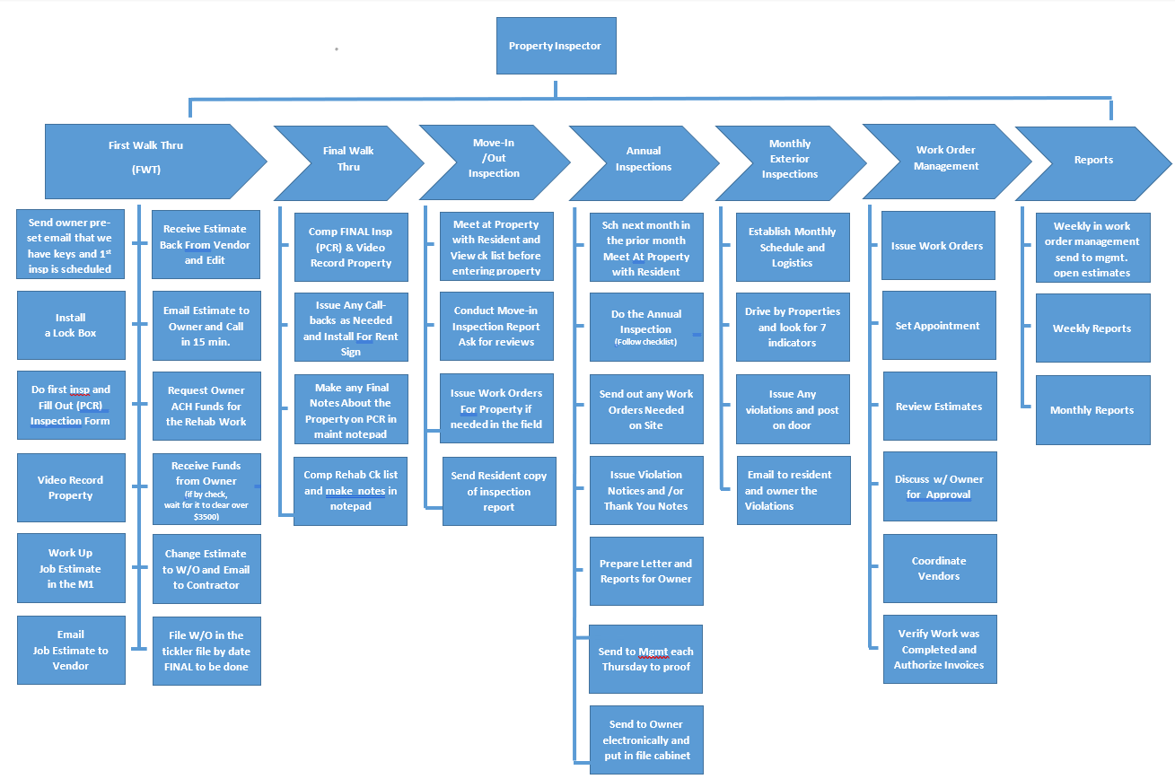

Components Of Maintenance
Computer Work Station Area
Computer
Printer
Monitorx2
Tickler file
Forms in peneflex
Overhead cabinet to hold rehabs manuals
Vehicle and components
See inventory list
View Video
Inspector Tools
Tablet
Wrist for tape for posting notices
Wrist band for labeling in Rehab
Uniform
Smoke Detector Checker
Key box for keys and remotes.

Task Priority When Coming In From The Field
- Ask your associates to give you 45 minutes to get data entered in the M1 software before answering their questions.
- Update in the M1 program (FWT, WF, WBD, WBDO, COM)- Availability dates from inspections you did that day)
- Update ILR and RML
- Pick up messages from voice mail
- Check E-mail
- Send out work orders to repairmen on properties where funds have been received
- Put items from your inspections in work box and start with the first item and follow The Company’s “One Touch System”
- Scan into M1 any walk-through forms, inspection forms etc. and then file them in the hard copy property file.
Miscellaneous Procedures
The property inspector position requires a variety of duties that either do not fall into a specific category or may cross over into the Customer Service responsibility area. You should be familiar with the practices of all areas of activities associated with property maintenance.

Walk-Through Inspections (Rehab Process Schedule)
Getting a vacant property ready for move in is known as “Rehab”. In order to be consistent and not overlook any area that needs to be addressed, a system has been created to complete the first walk through inspection, repairs and final walk through inspection of the rehab process. It is the inspector’s responsibility to update the information daily in M1 Software as each stage is completed. There are 20 days (start to finish) allotted to complete the rehab. Therefore, it is crucial to stay organized, follow the system, and follow up with Vendors and owners to meet each deadline. Here is an example of the approximate rehab schedule: (Assume FWT is on a Tuesday)
Day 1: 1AA Send owner preset email, we have the keys& Process
1A. First Walk Through Inspection (FWT)
1. Work up Job Estimate
2. Email work estimate to Vendor from M1Software
3. Send owner email that have completed your FWT and will contact him in about 48hrs
Day 3: Receive estimate from Vendor or Vendors via M1 Vendor portal (You will be notified by Email)
1. Edit your Job Estimate based on any estimates you received from your vendor
2. Email Job Estimate to Owner ( New Owner call first then send email.)
3. Call owner to go over Job Est and request funds to be sent in Via Email ( Recommend not having them mail it)
Day 4-8: Receive funds from owner. If funds are over $3,500 work orders can’t be issued until funds clear the bank, typically 2-3 Business days.
1. Accounting will let you know the funds cleared.
2. Issue Work Orders and schedule your final walk through date in your calendar. (Give Vendor 1 bus day for every $1000 worth of repairs, Plus 2 bus days for cleaning that needs to be done.)
Day 12-18: Final Walk Through or Request Vendor to go back for any pick up items.
Day 20: Final Walk Through (Drop Dead Date)
The biggest delay will be awaiting funds from owners. Since you are able to accept checks by fax, email or receive funds electronically, this should provide adequate time to get work completed and a final inspection done prior to the scheduled resident move-in, periodically, back-ordered parts or carpet may delay the rehab, therefore it is critical to complete the early stages as quickly as possible. Your clear communication with the owner with a sense of urgency to have funds remitted ASAP will aid in your success to complete all work within the time frames allotted.
Send this to the owner with the Job Est in a separate email. If owner does the work they must do all including cleaning and give a time it will be done within 30 days or less.

Rehab Process in-between Residents
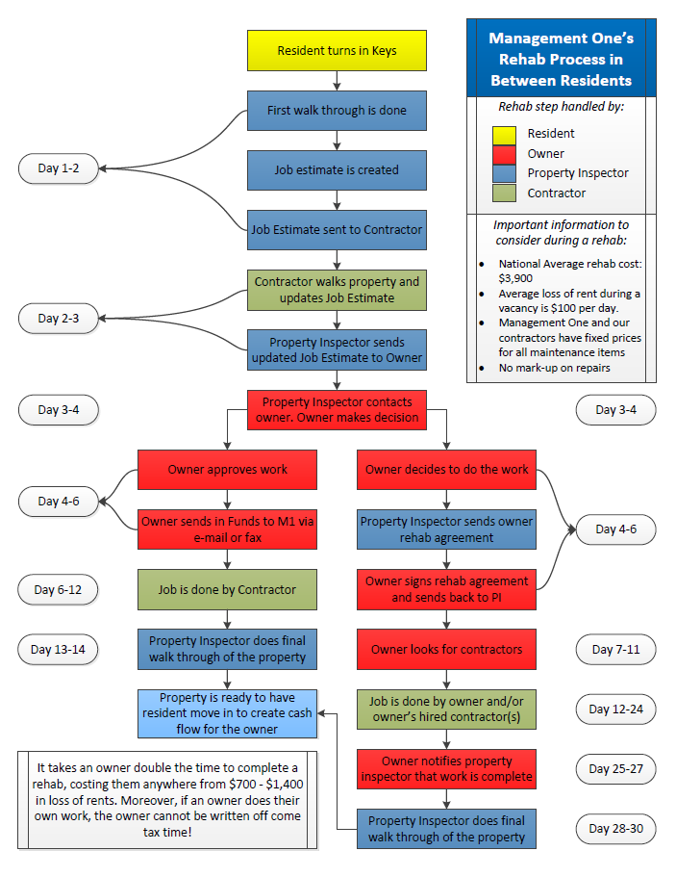

Rehab Maintenance Checklist
The Rehab Maintenance Checklist is the accompanying Cover Sheet for each Property File which a Property Inspector has for each upcoming Rehab Inspection that is scheduled.
This can be due to a Resident Moving Out and a Back on Market (BOM) being issued or it can be due to a New Account being signed and an Owner is Moving Out or the Owner's Resident will be vacating the home.
The Checklist is followed throughout the Rehab Process and helps to determine whether the Rehab Schedule is on track and managed properly. It also outlines the Protocol to follow for the Rehab Process so that all elements are addressed timely and in compliance.

Rehab Maintenance Checklist Form
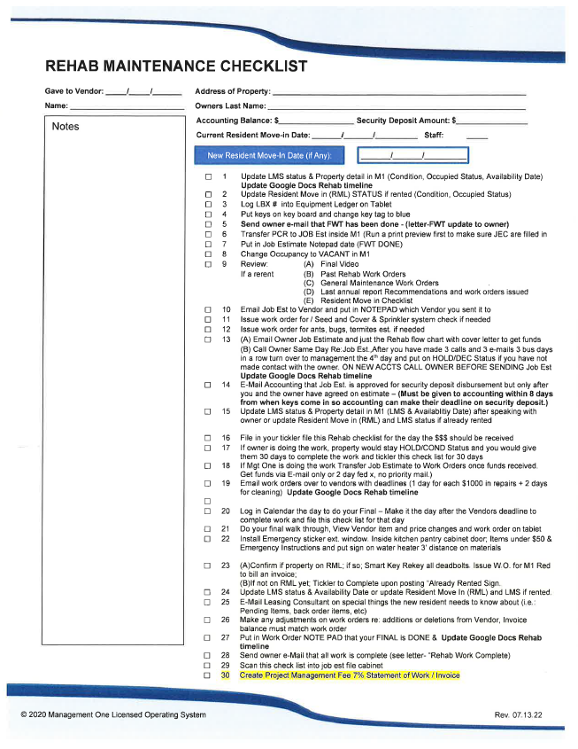

First Walk-Through (Vacant Property, Resident, Or Owner Move Out)
When a resident gives a 30 Day Notice to vacate, the FWT should be scheduled into your calendar for the day following their move out. When a contract is signed with a new owner, the agreed upon inspection date will also be put on your calendar again for the day after their move-out date.
Before leaving the office for an inspection, make certain that: (View Video on
Your Tablet has been charged. (Charge 100% each evening ). You are also advised to charge the tablet on the go using an inverter or car charger.
Check the vehicle inventory for a lock box (for each property you will doing a FWT inspection that day)
Take the keys and fobs to the property with you. (Use carrying tray provided )
Take all Garage Remotes with you to check if working (Use carrying tray provided )
If it’s a resident move out, view the previous rehab work orders on tablet.
Once you arrive at the property you start your inspection inside your vehicle on your tablet, go to “Rehab Inspections” Tab on Tablet (See Video on process).
Note, you will open any and all blinds and raise them about half way so you have plenty of light to complete your inspection and turn on any lights for further illumination.
You will walk the property from left to right once you enter the interior (clock-wise). This will keep the numbering of bedrooms and baths consistent with every property and will eliminate confusion with the Vendors. Whatever bedroom is the master, it sometimes is helpful to mark that on the report for further clarification. Some homes have dual masters, family rooms, offices, or lofts that may need to be specified when appropriate. While inspecting the property, you will start the dishwasher and air conditioner/heater or other appliances to check if they are operational. By sure to turn HVAC back off when you leave. Leave your key tray by the AC/Heater to remind you.

Video And Photo Documentation
You will video tape each room as you inspect it and document the condition of that room with audio narration. Then continue walking the house from left to right, paying special note to any items that may require special attention or note for file. You may find it necessary to get close ups of areas to provide a more definite impression of what you are trying to capture while speaking. For example, holes in walls, loose fixtures, cracks, or other areas of damage. Speak in a clear voice and loud enough to be heard during the playback portion. This is a documentary recording and can be used in a court of law as evidence, so be thorough. However, you do not have to film every minute detail and create an epic feature film. Use your best judgment. Ideal video time should be about one minute per room or less.
Anything you are going to charge a resident for you must take a still shot as well, which you can do from the tablet, so you have evidence as some courts won’t take video.
Having completed each room, you can pull down the blinds and close them as you go to the next room so when you inspected your last room you can lock the door and leave. This will save time and once the filming the house is complete the home will be secured and you will be ready to go. Let the dishwasher continue to run so all the water gets out of it but make sure the air conditioner/furnace are turned off before leaving the property as well as any lights, sprinklers, ceiling fans etc. that you may have turned on. Place the keys in the lock box at the front door so they will be available for the Vendors. Also install a electronic LBX for leasing with the property is ready to go on the market. You will install a for rent sign when you do your final.

Completing FWT Rehab Inspections
Once you return to the office, you will:
- Fill out the FWT/Rehab check list sheet to start your checklist. This is a hard copy checklist that follows the rehab but will be updated via the field tablet in the future.
- Complete and attend to items on the checklist appropriate to condition of property, making sure you update the (ILR) For Rent list or Move-in List (RML) in M1 and the (LMS) and adjust your availability date as well on the property. All these items are on your rehab check list.
- Email the owner that the FWT has been completed. This can be found, pre filled out, in the Letters to Owner section of M1.
- Find and view the video from the prior rehab, if there was one. Usually this will be in the PCR section of the property, but rarely it may still be on video tape. View this file from the prior resident (if applicable) as you work up your estimate in M1. This will assist in your determination of who is responsible for the repairs needed on the property (resident or owner).
- Print Preview the PCR. This will show you if you missed any JEC’s (Job Estimate Categories). If missed, these items will not carry over to the job estimate, and items will not get done.
- Generate the JE (Job Estimate). All of the items that were previewed on the PCR with JEC’s will populate. You will have a column for resident cost items (abused or missing items) and a column for owner expense items (wear and tear) and a third column that tallies the two.
- Assign the responsibility of who is liable for what, resident or owner. This will be noted on the PCR itself.
- Decide whether the repairs are Mandatory or Optional. Recommended items are entered into their own category on a PCR, denoted _Recommended. These are the “Hey, it would be a good idea to…” sort of items, but will not necessarily keep a property from renting.
- Send the Job Estimate to the General Contractor. The general will walk the property a second time, and will fill in anything that you cannot price out, and will likely finds items you did not, and price them out as well.
- Receive the JE back, Edit the JE. The general will send you back any changes to the JE. Edit the JE with these changes, but also really consider them.
Once completed, add in the Project Management Fee (7%), tally again, then the 3.5% credit card fee, and tally again. The CC fee will be deleted if a property owner is not using a credit card.
- Email the job estimate to the property owner. Be sure to first add the custom verbiage to the emailed JE. (If this a new owner call first before sending JE and when you do send JE to owner have them confirm they received as sometimes it will go to their junk mail. Have owner white list meaning have them make you a contact in their gmail or outlook so it does not go to junk mail.
- Call and Email the property owner. Call three successive days, then turn the job estimate over to management for direction and assistance. On the 3rd time send it through your regular email as well.
Use the 3 “F’s” for “Feel, Felt Found” to negotiate. Use the phrase, “by the way” to move the conversation where you need it to go and to enable you to have better time management. Do not get “into the weeds,” meaning going through a line-by-line recitation of the job estimate.
- Owner approves the job estimate and $ amount. Now arrange payment. Bear in mind that the contractor will not see a dime until work is fully completed and to M1 standards. Do not let an owner mails in funds (USPS) as it will delay the start of the rehab by days, and each day translates to about $100’s lost by the owner.
- Funds arrive – and clear. Any rehab fund checks over $3500 musty clear the bank before a rehab work oerder can be issued for completion.
The processes above ought to be complete inside of a week, tops.
There may be items that you recommend be completed but are not considered mandatory during the rehab. You will put these in the _Recommended section.

Some items may not be listed on the price sheet and must be filled in by the Vendor. This is common with carpet replacement. You will list the item on the estimate and follow the description with “est?” and put the relative price per the price list and then have the Vendor adjust the price if needed. Example: If you know the square footage of replacement carpet area is 1200 sq ft, take off 400 sq ft for enter , kitchen and bathrooms which have tile or vinyl, this would leave would be 800 sq ft for carpet, divide by 9 to get the square yards needed. 88 sq yards. Round it toi 134. Say the price per square yard for carpet is $21.00, multiply 134 x 21.00. Enter $1866.00. The Vendor will then measure the areas exactly and adjust the price. Don’t leave the price “$0.00” as the Vendor will have more flexibility on the pricing and might over charge.

There will also be times when you are uncertain as to the condition or means of repairing an item. You will list this item on the estimate and follow the line item description with “advise”. The Vendor will give you their opinion and a price to complete the repair.

You can then email the preliminary estimate to the Vendor (in M1).
After receiving the estimate back from Vendor in M1 (you will be notified by email when the estimate is sent back), you will revise your estimate total and contact the owner for a final discussion of the repairs needed and total funds that must be sent in to complete the work.
You will NOT issue any work orders until funds have been received from the owner and have cleared, if over $3500. Using Check by Fax, Email or electronic funds really helps to expedite this stage.

Once you have the final work order totals, you can send Job Est via email to accounting for disbursement of the resident’s security deposit. They will use it to compile the repair deductions for the security deposit disbursement along with any other fees, rent, etc that may be owed by the resident

Once the funds are received from the owner, you can issue the work orders. The exception is if funds are over $3,500, work orders can’t be issued until funds clear the bank, typically 36 hours. Accounting will call to ensure the funds cleared. Provide the Vendor with 4 business days in which to complete their work minimum, plus two days cleaning time. Remember, 1 business day of work for every $1,000 of work, plus two days for cleaning. Do not include the day you send it to the vendor.

Remember the following:
- After issuing rehab work orders for completion, insert the FINAL walk through in your calendar for the following business day.
- Be sure to tick off the items on your rehab check list as they are completed, and to log details such as “Called Owner re: JE”, or “Waiting Funds” right onto the job estimate itself.
- Put the Rehab Checklist into your ticklers for the FINAL Walk Though Date.
- Make sure you input the deadline on all work orders.
- Lawn and sprinkler repairs have to be done by the gardener, including complete seed and cover in a separate work order and or termite work or bug spraying. You’ll need to do a separate work order for this. Since they do the temp lawn or perm lawn they will be responsible for the germination, and keeping the lawn looking green.
- Be sure to update the Move-in List (RML)with and status changes if the property is already rented and change the For Rent List if the property is still on the market
- Be sure to follow-up about every other day on your work order status in M1 by viewing the open work order report.
Your paperwork will be placed in your tickler file for follow up with date notations in the left margin of the Rehab checklist. (The checklist will continue to move through the tickler file throughout the entire rehab process) DO NOT look at this file everyday there is no need.
- It is a good practice to confirm with the Vendor that they received the work orders and can finish the work in the desired time frame. We recommend giving Vendors 1 day for every $1000 worth of work to be done with a minimum of 4 work days for any kind of rehab you’re doing, plus 2 days for cleaning.
- Map out your day at your desk with the GPS. Use your Route Management on your tablet which you can access from your desk top as well. This will save you another 20 min a day.

First Walk Through (Owner Move-Out)
If an owner elects to complete the work themselves, they must sign an agreement to complete the work in the same four business days + 2 days for cleaning allowed for a Company Vendor according to our market standards. (No exceptions.) This form is called an RA agreement or “Rehab Maintenance Agreement”. This practice keeps owners accountable and on schedule. The Company does not recommend that owners complete their own work unless they have proven they can comply with our schedules and workmanship. It is a good practice to stay in regular contact with owners to be sure they are on track with all repairs and are on schedule for your completion dates. IF owner does not sign this agreement contact management for a conf call with the owner.
*Always call the day before on an owner move out or when owners are doing their own work.*
Codes for computer changes in Internal Leasing Report (ILR) and (RML) in M1 are:
OCC = (occupied) move in will be 17+ days out (Hold-Cond)
FWT = (first walk through) move in will be 15 days out (Hold-Cond)
WF = (waiting for funds) move in will be 12 days out (Hold- Cond)
WBDO = (work being done by owner) move in will be 12 days out
WBD = (work being done) move in will be 8 days out
Ready = (not rented but completed) ready for move in

Problem Resolution
When an owner does not meet their deadlines they can be fined, and you have to tell them why.
First when they say something like “Well, it’s my property”, your response is, “You’re absolutely right, however, when you signed the management agreement, you kept the deed rights, but you gave us the leasing rights, as well as the authority to manage your property. You also agreed in the management agreement to meet your deadlines. This is a partnership, as The Company has to meet its deadlines as well. When you sign the contract in good faith, we can tell the resident certain things based on what you agreed to, and when you don’t live up to your end of the required obligations.
Lastly, you will have to make your mortgage payment until it re-rents which could be XXX months in this market. So you could be looking at a $2000 to $5,000 loss, so this needs to be taken seriously to save you money.”

By monitoring and updating your completion dates on a daily basis, you will see how critical it is to stay on track in order for the resident to move in on time.

Final Walk-Through Inspection (See Video For Process)
Click here to Watch Live Video Process
Click here to Watch Video Report Tutorial
The First Walk Through documents the property immediately after a resident vacates in order to have supporting evidence behind any charges to the resident’s security deposit. The Final Walk Through documents the condition of the property prior to the new resident’s move in and will be compared to the property’s condition when that resident moves out and you conduct the property’s next First Walk Through.
When completing a Final Walk Through, you will view the work orders issued so that you can check the work that has been completed against the work which you have requested. (We recommend opening up a second browser so you have work order and items that were to be done on one browser and the one you’re filling out in another browser the final inspection this way you can tab back and forth very quickly) (See Video on this is best done) If you find some items are not done, you can check them odd as “Recall Items” on the work order and call the Vendor back out to complete them while you’re at the property. If for some reason, a call back is impossible, you may need to delete the items from the invoice completely and not pay for the item(s). Alert accounting immediately as it may affect the resident’s security deposit refund.
Be sure you have received a “final” fax or email from the Vendor before going to the property. If not, call to be sure they have completed the work. If an owner is doing their own work, call the owner beforehand to be sure they have completed all work on time. There is no sense in driving all the way to a property only to find out the work is not complete.
Final Inspection Walk Through is completed the same way the First Walk through Inspection was done. Follow the documentation procedures in the First Walk Through section of this manual. Using the same procedures as the First Walk Through, you will complete a “Rehab Inspections (PCR)” report noting this is the Final Walk through Inspection. The same procedure is also followed when videoing the property.
Upon entering the property, review that the work orders have been completed and in an acceptable manner, i.e., if a general clean was requested and you notice dirty blinds or light fixtures, you will need to call the Vendor and have them come back out to complete the job properly. It is at this time that you may periodically find something that you and the Vendor missed during the rehab. Make a note of it, so that it can be completed prior to the new resident move in or, if deadlines are tight, immediately after the Move-in Inspection.
After you return to the office you can make your final updates in M1 (We recommend doing this in the field on the tablet) as noted on your Rehab checklist. Follow up with the Vendor on any necessary items and complete your checklist.
If an owner has done their own work and has not completed all of the items or has not completed work to company standards, a work order may need to be issued to a company vendor to be completed as needed. The owner must be advised of their failure to comply with our recommendations. Advise the Leasing Department if the resident must be informed of any special circumstances prior to their move-in. Take all paperwork and scan it into the property File Cabinet in M1.

Monthly Exterior Inspection (See Video For Process)
Click here to Watch Live Video Process
Each month you will be required to drive by each property to inspect the exterior condition if the owner’s management agreement calls for it. You will enter into the “EXTERIOR INSPECTIONS” Tab on the tablet".
In it, you will note whether the resident has been abiding by the conditions of their rental agreement by keeping the grass watered and mowed, planters weeded, bushes trimmed, driveway free of oil and non-operable vehicles, trash cans put away, etc.

In the event you find a violation of the lease while you are conducting an inspection you will issue a Violation Notice to the resident requesting that they correct a particular item. You will do this by posting the notice on the front door of the property and email them and the owner of the violation.

The resident has 10 days in which to correct whatever your request was for. You will make a notation in the monthly exterior report that you issued a violation and what it was for. Once you go by the following month you can see they took action or not.

If the resident fails to comply with the original violation, you will issue a second notice with a $50 fine, the next month another violation and a $100 fire, the next month another violation and a $200 fine and bring it up to management. Then you will file “10 DAY NOTICE TO PERFORM COVENANT OR QUIT”. You will post this and/or put it in the mail. If this fails to get the desired results, contact management as we would be forced to issue a “3 DAY NOTICE TO PERFORM COVENANT OR QUIT”. These notices are both posted and mailed.
In the event no violations are written, this is your opportunity to notice what is going on at the property and in the neighborhood.

If the property is showing improvement as a result of the care the resident is taking of it, you should send a note thanking the resident and advising the owner of such. This can be done via email in M1 software.

Forms to Use
- Exterior Inspection Report (States 1st Notice or Final Notice on the same form) (FROM M1 software)
- 10 Day Notice to Perform Covenant or Quit (Report in M1 Legal Documents)
- 3 Day Notice to Perform Covenant or Quit. (Report in M1 Legal Documents)
- Warning Notices
- Violation Notices

Annual Inspections (See Video For Process)
Click here to Watch Live Video Process
Click here to Watch Video Report Tutorial
Company has agreed to provide every owner a complete inspection of their property on an annual basis, 90 days prior to the resident’s lease renewal.
The month before a month of annuals are to be completed, they will be scheduled in the calendar. Example: A lease renewal in April have their annual completed in January, but that will be scheduled in December.
The annual inspection report for a given month will be generated in the menu of M1. Properties will remain on the schedule report until they are marked complete in M1. All of properties on the report are to be inspected in the following month. An annual letter (found in M1-letters-Annual Inspection) will need to be sent to the resident advising them of their scheduled time and date. Residents will also be able to view their upcoming inspection month via their M1 resident portal. (In the future these inspections will be automatically added to your personal M1 calendar).

All annual inspections must be completed prior to the end of the month due. “Completed” means the report has been e-mailed to the owners as well as uploaded into M1 file cabinet.

You will email a PDF of the report to the owner. If they do not have an email address, you will mail them a copy.

When residents do not cooperate in scheduling the inspection, you may be forced to post a 24 HR Notice to ENTER (found in the M1 Legal Documents) and complete the inspection without them being home. A resident can also give you permission in writing to enter the property without them being there if they choose. A neighbor or friend can also be present when the resident is unavailable. Children under the age of 18, without an adult present, cannot be alone during an annual inspection. You are not allowed to enter the property when there are minor children present without an adult.

An annual inspection is a general inspection of the interior and exterior of the property. You are making certain that everything is in good working order and are taking this opportunity to make recommendations for preventative as well as critical maintenance items. This may be one of the only times you will be able to view the interior of the property and evaluate the care the resident is taking of the house in regard to the property’s cleanliness, wear and tear items, painting, etc. You will be able to evaluate if additional people, not listed on the lease are living at the property, unauthorized or indoor pets are present, and can take immediate action with the resident.

You will test the smoke and carbon monoxide detectors, replacing any that are outdated or do not function properly.

Although the inspection itself takes a short amount of time (typically 15-20 minutes), your report can prepare the owner for whether their next rehab costs will be substantial or not, or whether you will extend another lease option to the resident.

You can start your inspection by taking a photo of the front yard and noting it’s condition and anything that needs attention.

Once inside, you will inspect the property from left to right. You will take a photo of each room present. In kitchen and bathrooms, you will look under sinks for any water leaks. In bathrooms you will check the toilet wax rings. Photos taken of bathrooms and kitchens will be taken shoeing as much of the room as you can with the sink cabinet doors open.

Address any compelling issues with the resident. Take photos of anything major that needs attention such as torn carpet or water damage, tree trimming, etc.

Complete the Annual Report in the field from your tablet and issue work orders and violations in field. Complete your entire annual in the field and send to your manager each Thursday to approve before sending to the owner.

Once completed and sent to the owner you will uploaded the annual into the M1 file cabinet.

Move-Out Inspections (See Video For Process)
Click here to Watch Live Video Process
Click here to Watch Video Report Tutorial
Once a resident submits a 30 day notice, a letter is sent to them from the accounting department advising them to call and schedule their move-out inspection.

If the resident does not call, you’re not required to do it. (Check with your city or state regulations)

The inspection needs to be scheduled no more than 14 days prior and no less that 5 days from the move-out date. The purpose of the move-out inspection is to simply view the property and give the resident a copy of the cleaning checklist. Usually the home still has furniture in it and you will not be able to do cosmetic and structural inspections that are completed when doing a FWT. When the resident vacates the home, they might put a hole in the wall with the furniture or there might be a stain on the carpet that has been covered up so this is why we don’t discuss actual damage costs with the resident at the move out. Try to encourage the resident to sign the cleaning checklist to save them time. They know exactly how much that will cost.
You can find the cleaning checklist in M1 in Leasing/Forms/Cleaning Checklist. Agree to nothing. Often resident will have a “friend” there (a witness) and the resident will say things to the effect of “Hey, looks pretty good, right?” You agreeing with that statement will come back to haunt you and the company in court later.

You will use the “Resident Move-Out Checklist” form in M1 software to be completed while touring the house left to right. Once the inspection is complete you will have the resident sign it. This form will then be emailed to the resident and sent to the residents file cabinet inside of M1.

Move-In Inspections (See Video for Process)
Click here to Watch Live Video Process
Click here to Watch Video Report Tutorial
When the residents sign their lease, The Company will schedule an inspection within 10 days of them taking occupancy of the property. The primary purpose of this inspection is to document any items for the file the resident deems to be important with regard to the condition of the property. This also provides a time to note any items that were not discovered during the rehab. After daily operation of plugs, toilets, stoves, lights, etc. the resident may have found some items to not be functioning properly that a more cursory First Walk Through Inspection did not discover.

Exterior locks are changed/rekeyed prior to move in. A work order is issued to a locksmith to have completed within 48 hours prior to move in.

You will use the “Move In/Move Out Inspection Tab” on tablet in the Tablet Menu.

Once the inspection is complete, the resident will sign it on the tablet and the copy is emailed to the resident and a copy is sent to the residents file cabinet inside of M1.
The “For Rent” sign and any accompanying “riders” will be taken down and removed and the lock box will also be removed, it it wasn’t already.

Work orders are then issued for minor repairs and will be issued in the field on the tablet before going to the next inspection. This way you’re 100% done with this inspection in the field. If there are more major items, then the owner can be contacted for approval or estimates requested once back at the office or on route to the next inspection as well.

If you are issuing over 3 work orders after a move-in inspection, then your Rehab was not detailed enough, so you will need to slow down and make it better.

Tell residents that repairs will be done in 7-14 days unless it’s a heating/cooling, plumbing or security issue. Then in the next 36-72 business hours it can be repairman in most cases.

Installing For Rent Yard Signs
Click Here to watch a Instructional Video
Putting up a “For Rent” sign is done within 3 business days of when the property is first placed on the market. The majority of the time the property will still be occupied. Please see the next page where it also states when the sign goes up.
- Use the auger to form the hole the stake will go into. Use the sledge hammer in necessary to make sure the bottom of the post is at ground level.
- Install sign so it is level
- Paint post as needed
- Clean signs if dirty before installing
- Log sign post in the equipment ledger as being at that property.
- Take photos of property front
- If lawn needs fertilizing or reseeding send a work order out to be done
- Observe and act on any other items that need addressing.
Your marketing of the property starts the day the sign goes in the yard.

Equipment
SIGNS
Signs reflect the company’s public image and are also a marketing tool to attract new accounts. Signs should be clean and in good condition. Posts should be routinely painted to keep them looking fresh.

Installation- When a resident submits a 30 Day Notice to vacate and the property is put back on the market for rent or a new account is signed, a sign should be installed immediately in order to provide maximum exposure and reduce vacancy time. Signs are installed in a professional manner (straight, good condition) and in a place easily visible to street traffic. Each time a sign is installed, it will be noted on the Equipment Inventory Ledger on the tablet.
Pictures of the property will also be taken at this time for advertising on the internet.

Once a property has rented, the “Already Rented” sign should be attached as soon as possible to the existing sign. This provides a resource for marketing that shows we have done our job. Log this in your “Equipment Inventory Ledger” on your tablet.

Removal-the sign and any riders are removed when performing the Move-in Inspection with the resident. The resident has been advised NOT to remove the sign themselves. If they have taken the sign down and it has become damaged in the process, they can be held liable for its replacement. Once removed, you will again make a note on your sign inventory log.

Sometimes signs become damaged during extreme weather conditions. If you discover a sign has been damaged by wind, etc. you will repair, remove or replace it, as the situation warrants.

LOCK BOXES
During your first walk through inspections, a reg lock box and a electronic LBX will be installed to provide access for Vendors, staff, etc. When you install a lock box, LBX number will be entered on your “Equipment Inventory Ledger” log as being on that property. When you conduct your Move-In Inspection, the lock box is removed and logged again as checked in on the “Equipment Inventory Ledger”.

FORMS/SUPPLIES
It is your responsibility to monitor your inventory and keep an adequate supply of forms, paint, hardware, locks, etc. stocked in your vehicle at all times. A vehicle inventory list is attached for your review. Being organized can save time and create an environment for success.

Job Estimates
Whenever a repair cost exceeds the amount agreed to in the owners’ contract, an estimate is provided to them for approval. There are times when a repair becomes a mandatory item because of habitability, liability, or securing concerns for the resident, and although an estimate is provided to the owner, there is an expectation they will make immediate arrangements for payment. Below you can review the steps taken when a general repair is requested and its cost exceeds the amount allowed.
Resident requests repair
Work order issued to Vendor to provide estimate with a deadline for response
Estimate received
Owner is contacted by phone, email, or mail. See appropriate memo to attach, with a deadline to respond with approval or denial. These memos can be found in M1-Letters-Maintenance
Approval is given
Funds received and retained in accounting
Work order issued for completion (WORK ORDERS ARE NEVER ISSUED UNTIL FUNDS ARE RECEIVED)
Repair made
If not a mandatory repair and denied by the owner, you will notify the resident that the owner is not in a position to make the repair at this time. Refer to M1-Letters-Maintenance for the various letters to use.
If repair is mandatory because of habitability etc, and owner is unable or unwilling to provide funds, see management. Funds will need to be retained in the owner’s account to pay for the necessary repair. Under normal circumstances, owners are willing to maintain their properties so as not to jeopardize their investment and avoid any legal ramifications.
Once a repair is made and the invoice is received, compare estimate and approval amount to the billing amount to approve for payment.

Notices
There are times when notices must be posted to comply with legal requirements. These notices include:
3 DAY NOTICE Posted on the 6th of the month when rent has not been paid or whatever your company as set up. A copy of this notice is also mailed to the resident.
24 HR NOTICE TO ENTER This is posted when resident has not responded to requests to show property when up for rent, when resident has not responded to requests to schedule annual inspections, under other circumstances when property needs to be checked and resident has not responded to our requests to make an appointment to have access to the home.
10 DAY NOTICE TO PERFORM COVENANT OR QUIT This is posted and mailed to the resident when they have not complied with the terms of their agreement or have not responded timely to a request to correct a violation posted on the Exterior Inspection Report. HOA violations, exterior maintenance, unauthorized residents, unauthorized pets, etc. are typical reasons to post this notice.
3 DAY NOTICE TO PERFORM COVENANT OR QUIT This notice is posted when the 10 DAY NOTICE has not been complied with or when there is a more pressing nature of the violation of their lease agreement.
EXTERIOR INSPECTION VIOLATION This notice is posted during the monthly exterior inspections and gives the resident an opportunity to correct a situation in a cooperative manner. This also provides legal documentation of the condition of the property. If the resident chronically refuses to maintain it according to the conditions of their lease agreement. A memo is sent to the owner when an exterior violation is issued to keep them updated on our activity in managing their property and corrective action we are taking.
All notices are to be filed in your tickler file for the appropriate days for follow up. Once resolved, the resident will be notified with a “thank you” email, and the owner will be notified of compliance. This is generated from the exterior inspection module directly.

Vehicle Maintenance
Click here to download and customize your vehicle maintenance log.
The van must be maintained in order to efficiently complete all activity related to the field. Because it reflects the company’s image to the public, it should be kept clean and in good repair at all times. It must be serviced every month with oil changes, scheduled maintenance, tire rotation, etc. A vehicle maintenance log has been provided for your convenience and will be part of the monthly reports submitted to management. Lastly you must check all fluids and tire pressure each Monday this is part of your job Description.

Maintenance Service Record
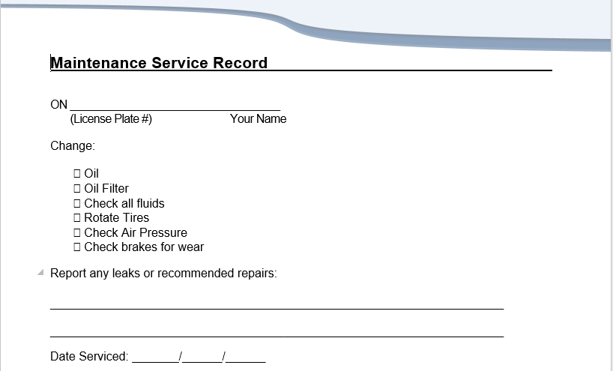

Repairs
The Company has an agreement with the owners to not issue work orders for repairs that cost in excess of the amount stated in their contract. In the event an emergency (habitability) repair becomes necessary, i.e., water heater, roof leak, etc., the work order can be issued, however, the owner should be contacted first and advised of the emergency. The owner must be advised to send in funds immediately and/or accounting must be notified to hold funds in the property’s account. If unable to reach personally by phone, messages should be left at home and work, email and memo sent in mail to advise the owner of type of action taken and approximate costs involved.
Procedures require estimates be provided to the owner for repairs costing over the stated limit. This can be done by mail, phone, fax, email, etc. See procedures in estimates for further detail.

Residents are encouraged to make minor repairs themselves.
The Company does not reimburse for repairs in most cases. This saves the owner the additional cost for a Vendor and allows the resident to get the repair done at their own convenience.

If a resident requests to make improvements to the property, out of the normal scope of daily maintenance items, they must first request and The Company will attempt to receive written approval by the owner.

When repairs are needed, they are requested by the owner or resident.
During an annual or exterior inspection, you may also note that a repair is necessary and issue a work order for it. When you issue a work order for a repair, it must be issued to an approved Vendor and should contain a brief description of the repair needed as well as the resident’s day and evening contact phone numbers. This will allow the Vendor to efficiently schedule an appointment with the resident to complete the work.
There are times when residents request repairs be made that they are responsible for. The costs associated with them, i.e., plumbing clogs, garbage disposal repairs, etc. can be passed back to the resident. When the resident calls in to request the repair, they should be reminded that they may be responsible if there has been any abuse on their part. The Vendor will note if the repair was the resident’s responsibility on his invoice and accounting will collect from the resident.

Time Busters For The Property Inspector
The following are key areas that will waste time and put you behind schedule quickly.
Keys that don’t work
Waiting for keys to be made
Owners and resident not moving out on time. Call before you go to verify
Vendor not 100% complete or not sending in a “Final” by email
Making more than 2 trips per rehab
No AC to charge Tablet or Laptop in Vehicle
Not having lock box ready to install in van
Not working up your job estimate the same day you do a FWT
Not having the light for the proper camera operation
Not having owners sign maintenance agreements when they do their own work
Not sending out a memo the first day you do a FWT if you do not personally talk to the owner.
Not calling every day to reach the owner for approvals after 3 work day bring up to management
Letting owners send in funds by regular mail instead of fax check, e-mail, credit card or FedEx.
Note: Average time to complete a rehab from A-Z is approximately 3.5 hours. This includes driving time, FWT, Final, Working up Job Estimate, paperwork, calling owners, etc.

Recommendations To Owners
(The resident market requires the following: Please remember they are your customer as well as ours: Think of your resident as a customer walking into a department store, rather than looking at them as just a resident)
If you yourself are painting, or if you’re having your own Vendors paint, please follow the following procedures to avoid re-painting again and again:
- Use a quality paint Vista or Dunn Edwards.
- Complete in a bedroom means closet and closet doors as well as the walls.
- Complete in Bathrooms and Kitchens means Ceilings are to be done as well
- Use a Water base semi-gloss paint DO NOT USE FLAT PAINT
- Make sure that the ceilings are cut in and roller marks are not left on the ceiling
- If the room is a color other than white you will need to give it 2 coats otherwise it will bleed through.
- Spot painting is not permissible unless you have an exact match and the paint that is on the wall is less than a year old. 99% of the time you need to paint the whole wall.
- If you remove curtain rods you have to patch and texture the holes, just patching is NOT acceptable. You can buy texture in a can at Home Depot for $15.00.
Lawns/Sprinklers and Landscaping:
1. Auto sprinklers are essential if you want to attract a good quality resident. Once the house is vacant there is no one there to water the lawn each day. Think of the front the lawn as a cover to a book or the front of your business card or place of business itself. If it looks awful why would you want to read the book or worse yet do business with that person? (Answer is you wouldn’t and that means more vacancies for you and double mortgage payments) That’s what residents in surveys have told us about properties with horrible lawns. If you can’t afford that right now then get a neighbor for $50 a month to water it until the house is rented. However put it in your goals to have an auto system with timers in place before the next resident vacates.
2. Do the lawns first especially before you work on the inside of the property.
(Seed and fertilize or in the winter you can use winter rye and in 10 days you have a great lawn or in summer use Grassology)
- If you have trash to haul away, trimming of hedges or weeding of flower beds that to needs to be done first.
Cleaning:
Residents put more weight on cleaning if they will rent your property, or not, than anything else and it’s the least owners spend money on. You cannot skimp on cleaning and just because you use a professional cleaning service does not mean it will be professional. We rent your property on the basis that it will be certain standards of cleanliness before you even get the work done. Therefore, in order to rent your property faster we have to know when it’s all said and done that you have given us the property in the condition we sold the resident on renting your property on. If it’s less than that they will back out at the last minute and you don’t want that. See the attached sheet (cleaning checklist) and if you have a person cleaning for you go over it in detail with them and make it them check each item off and then you need re check it before you pay them.
Misc:
Up and above what is on the Job Estimate we sent you, if you find other misc. repairs that are needed, such switch plates, door stops, light bulbs, etc. do them at this time.

Property Inspector Processes
BEFORE LEAVING FOR THE FIELD CHECK THE FOLLOWING:
FWT
- LBX
- 3 sets of keys/ and or fobs and gate keys if any
- Orange or tape and green stickers or tape
- Get Date Resident Moved In
- Get Amount Spent on Prior Painting, Cleaning & Misc
MOVE IN INSPECTION CHECKLIST:
- When arriving at the property hand the residents a business card.
- Explain that we did 180 point inspection in writing prior to move in.
- Explain we did a detailed video of every square inch of the property.
- If they have a list you will put everything on move in list. (Don’t take their list)
- Hand them Emergency hand out. (Tape to inside kitchen cabinet) This ought to have already been placed there at the FINAL.
- Ask them to walk property from left to right with you. Take control
- Have them sign the move in inspection on tablet
- Get their latest email
- Get their latest cell phone number and house number.
- Tell them any work order will be done within 5-14 days.
- Take down “For Rent Sign”
- Take Lock box off front door if it is still present.
- Issue any work orders -In the field
- Save in Resident File Cabinet in M1 - In the field
ANNUAL INSPECTION:
- Hand them a business card.
- Hand them Emergency hand out. (Tape to inside kitchen cabinet) This ought to have already been placed there at the FINAL.
- Ask them to walk property from left to right with you.
- Look under all sinks for moisture.
- Check all smoke detectors and CO detectors
- Check water heater for straps and secure a Water Heater Sign to the water heater advising the resident to keep the area clear up to 36” out.
- Check self-closure on fire door.
- Be detailed in all rooms. Take pictures of all rooms
- Take pictures of front yard, all rooms, and the back yard.
- Issue any work orders -In the field
- Finish annual report in your vehicle on your tablet while at the property
- Mail or email report to owner depending on company policy
EXTERIOR INSPECTIONS:
- Be sure grass is cut and green
- Be sure flowerbeds are weeded and bushed trimmed.
- Check driveway for oil stains.
- All trash cans should be in backyard out of sight.
- Basketball hoop if not being used should be on side of house.
- Be sure all fencing looks good and not half way down.
- Check for multiple cars in driveway and parked in front of house.
- Check for overall cleanliness.
- If all of the above look bad, take a picture of same and backyard.
- If the yard looks bad and the house blinds are bent and drapes not hung properly you know the inside must be a mess. We may want to post a 24 hour notice to do an interior inspection.
- Serve a warning if needed
- Serve a violation notice if needed

How to Create a New Job Estimate
How to Create a New Job Estimate in the M1 Solutions Software

How to Create a New Job Estimate - Video

Click Here to Watch a Step-by-Step Tutorial Video

FAQ- Frequently Asked Maintenance Questions and Answers
Click Here to Download MS Word .docx file

Quick Reference Flip Chart
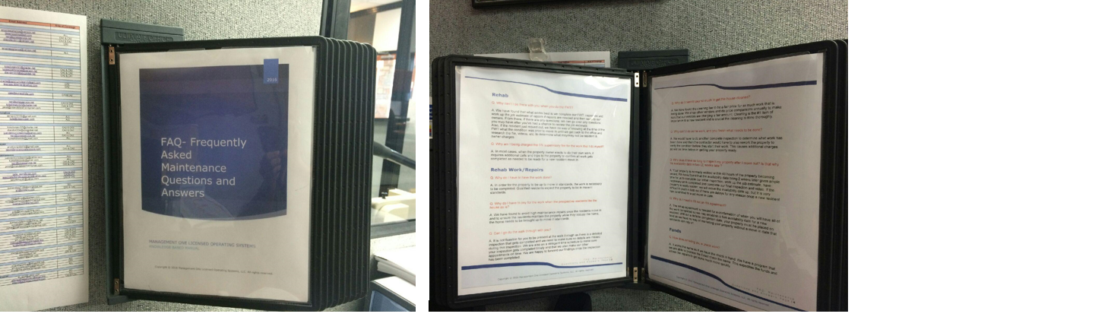
It is recommended that the following Frequently Asked Questions are printed and displayed in a Hanging Flip Chart in the Station or Cubical of the Leasing Consultant Division for Quick Reference.
This way the information is not hidden on the computer somewhere and it gives any new person the advantage they need for quick responses as well as providing superior customer service as they appear very knowledgeable from the very first day.
Click Here to acquire your own "Wall Reference Organizer"

PI Stadium speeches

PI Stadium speech for new owners
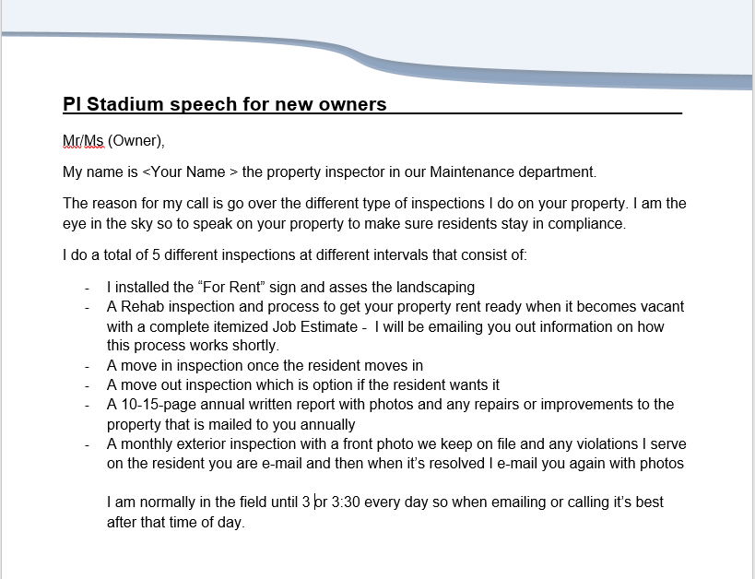
Click here to download and customize your speeches.

Stadium Speech for Owner- Email
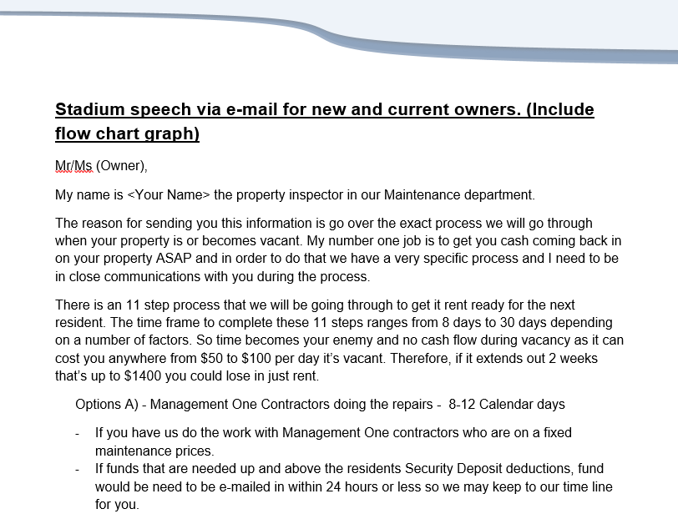
Click here to download and customize your email.

FAQ
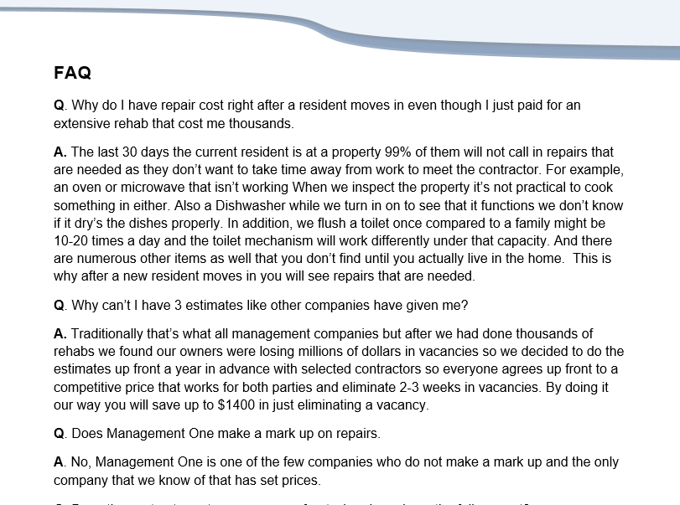
Click here to download and customize your FAQ.

Keyboard System
The keyboard is a color coded board which is labeled with the property address on each tag along with 3 hooks for sets of keys and relevant tags. The Color coded sections denotes the current level of occupancy/vacancy and correlates directly with 3 reports;
- (ILR) Internal Leasing Report
- (RML) Resident Move-in Ledger
- (COL) Close-Out Ledger

Keyboard Color Code
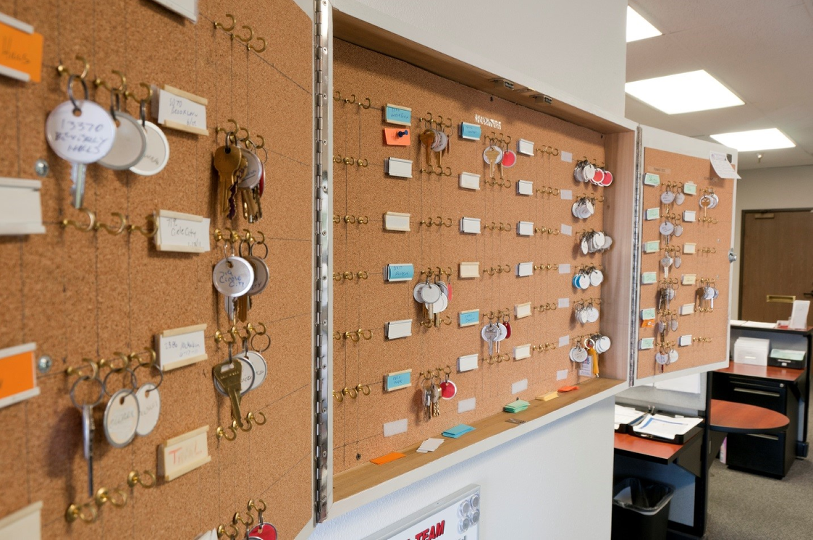
The keyboard is organized and segregated by 5 Colors which correlates directly with 3 reports; (ILR) Internal Leasing Report, (RML) Resident Move-in Ledger & the (COL) Close-Out Ledger; as well as denotes the current level of occupancy.
Orange- Owner occupied
Blue- Vacant
Green- Tenant occupied
White- Rented/Move-in
Yellow – Vacant and ready to rent

Color Categories Explained
Orange Label- Owner occupied
Owner is still occupying property so you cannot check out keys to this property to anyone and the property must be personally shown (3 sets of keys on the board at this time) (the property address & the scheduled move out date to be noted on the tag)
Blue Label - Vacant
Property is vacant (please note the Property Inspector must walk the property before it’s deemed vacant; an owner or a resident turning in keys is not considered vacant and details of this will be covered in training as to why) (2 sets of keys and a red tag on the board at this time) The property inspector will change the keys to a Blue Tag once the first walk through has been completed.
Green Label - Tenant occupied
Current Resident is still occupying the property so you cannot check out keys to this property to anyone (there would only be 1 set of keys on the board at this time) (The property address & scheduled move out date to be noted on the tag)
White Label - Rented / Move-in
Property is rented and waiting for the new resident to move in (1 set of keys if the property if still occupied; 2 sets of keys and a red tag if the property is vacant) (the property address & the scheduled move in date to be noted on the tag)
Yellow Label – Rehab completed and ready to rent

Key Board Statuses & Rental Categories
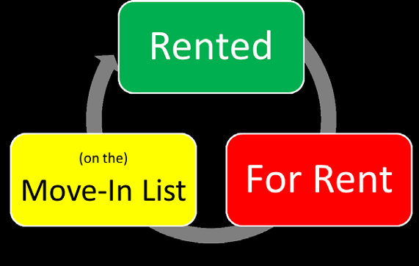
There are only 4 statuses a property will be in, within our inventory.
- For Rent
- Move-in
- Rented
- Closeout
There are only 4 categories that properties will come from, “for rent”, and will either have an (NPO) New Prospective Owner sheet or a (BOM) Back on Market sheet.
(N) New Accounts-NPO
(R) Re-rent-BOM
(E) Evictions-BOM
(B) Breaking of Lease-BOM

Additional Tags
White Tag with Writing ("Keys to be made") New Account
If Owner Occupied - An Owner is to turn in 3 sets of keys when the sign as a new account, however if the owner only has one set to turn in, the keys will be placed on the board with two tags that state "Keys to be Made" until the Property Inspector has been able to make copies.
White Tag with Writing (R - OCC) Resident Occupied
If Resident Occupied - When a property is a "Back-on-Market" or a "Closeout", then the one set of keys, kept on file in the office, will be placed on the board with two tags that state "Keys to be Made" until the Resident vacates and turns in the two sets they have.
White Tag with Writing ("Staff Member's Name") Keys are Checked Out
If a Staff member has checked keys out for a Showing or to Personally Show, they would replace the key set with a key tag that has their name on the board so that anyone can see who id responsible for the keys that are checked out.
White Tag with Writing ("Owner") Keys are Checked Out
If the property is Vacant, and the Owner has decided to manage the Rehab himself, he would then checkout a key from the office or may have his contractor check a key out. For each set of keys checked out, they would be replaced with a tag stating "Owner" so you know the owner has them. A checkout key form would also have been signed by the owner or their contractor.
3 sets of keys with White Address Tags (V - VAC) Vacant
The Occupant has vacated and all keys are on the board
Red Tag- Lockbox on property
One set of keys is taken from the board placed in a lockbox secured at the property on the front door. The Keys on the board are replaced with a Red Key Tag (this is only on vacant properties, once the First Walk Through (FWT) has been performed by the Property Inspector)
Green Tag- Electronic Lockbox on property
One set of keys is taken from the board placed in an electronic lockbox secured at the property on the front door. The Keys on the board are replaced with a green Key Tag (this is only on vacant properties that are ready to be shown and rented).

M1 Rehab Algorithm "For Rent" Inventory Tool
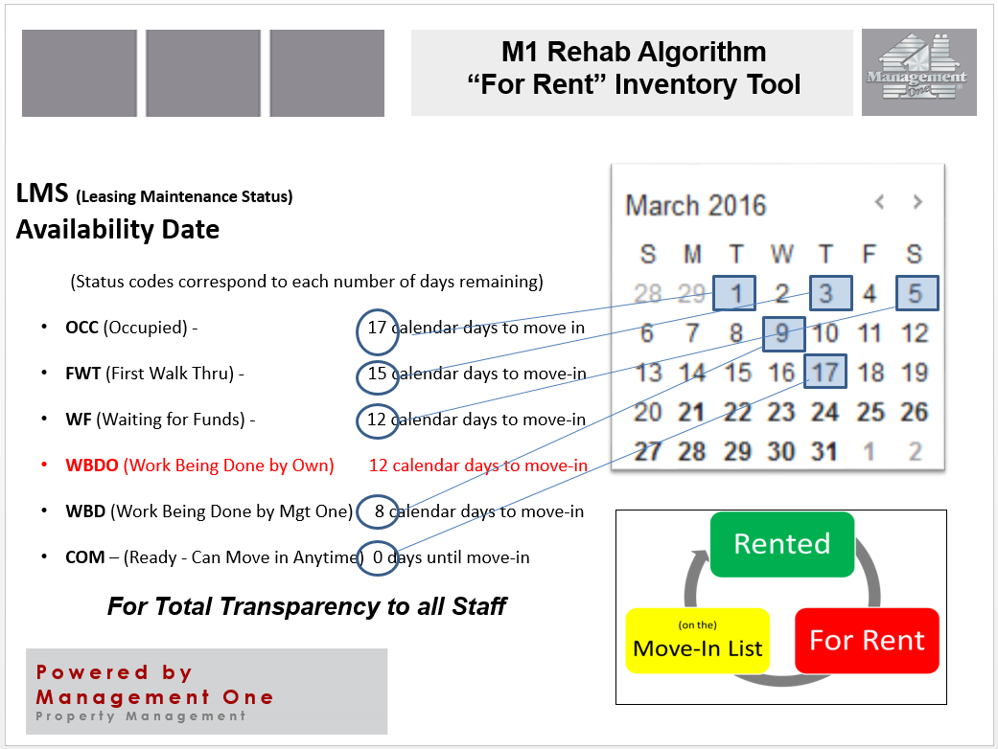
This Algorithm is used to determine the Date a property can be Available for a Resident to take possession.
NOTE this has been modified due to Cov-19 and company changes. See management.
To work this Algorithm, one must count down or count backwards, meaning on day one (i.e., the property is Vacant and the Property Inspector can perform his initial [FWT] First Walk Through) the schedule affords 17 days until the property is available for move-in.
As the schedule progresses each status acts as a milestone with a certain number of days afforded for that phase in the process. It will be very apparent if there is an issue in meeting the deadline to make this property available by the calculated date, if the property status does not correlate with the calculated days in the process. For example, if today's date is the 11th, and the property is committed to a New Resident to be ready on the 17th, then the status needs to be (WBD) Work Being Done in order to be on schedule. If the Status is still (WF) Waiting Funds from the owner, then the number of days available for the contractors to complete the work and the time needed for the Property Inspector to perform his Final Walk Through is now greatly restricted and chances are the Resident Move-in Date will have to be pushed out, which can cause a number of issues on all parties including expenses and scheduling.
-All Properties must correlate their position on the key board with their Occupancy Status and reflect their availability dependent on their (LMS) Leasing Maintenance Status as indicated in the (ILR) Internal Leasing Report and (RML) Resident Move In Ledger.

M1 Rehab Algorithm "For Rent" utilizing the Internal Leasing Report (ILR)
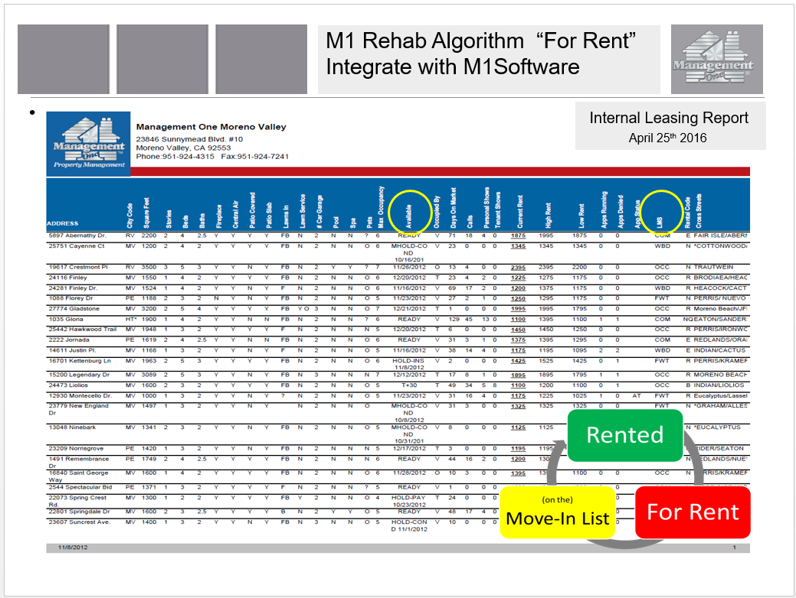

M1 Rehab Algorithm "For Rent" utilizing the Resident Move In Ledger (RML)
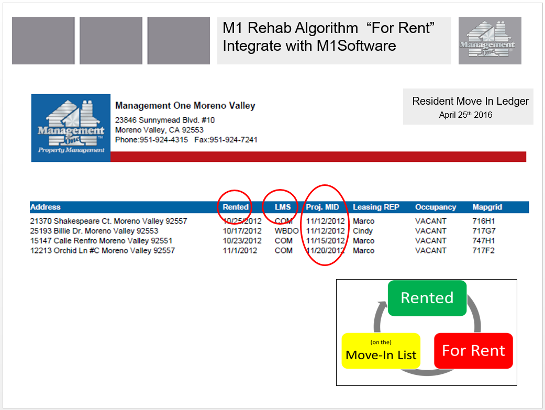

Key Board Protocol
-All Properties must correlate their position on the board with their Occupancy Status and reflect their availability dependent on their (LMS) Leasing Maintenance Status as indicated in the (ILR) Internal Leasing Report and (RML) Resident Move In Ledger.
-Every property on the key board must have 3 key tags
-New Accounts must have 3 sets of keys- if only 1 set is given, then there should be two tags which state “keys to be made” until they are made and hung on the keyboard.
-Back on Market (BOM) Properties will have 1 set of keys (from the office filing cabinet) and the other 2 hooks will have key tags which note “Resident Occupied”.
-Occupied status address labels will state the potential move-out / vacancy date.
-When a resident turns in all keys, the address tag and keys are not moved from “Green” to “Blue” until the Property inspector has walked the property and changes the (LMS) Leasing Maintenance Status on the (ILR) Internal Leasing Report, from “OCC” to “FWT”. The same goes for Owner occupied property; From “Orange” to “Blue”.
-When a property changes to (FWT) First Walk Thru status, one set of keys are taken off the key board and placed into a lock box which is left on the door knob of the rental property. This key hook is then marked with a “Red” key tag to note that a set of keys are in a lock box at the property.
-If the owner or his vendor needs a set of keys, one will be taken off the board and replaced with a key tag that states “Owner” to note the owner has a key.
-All keys must be signed out before released.
-If a key is taken off the board or checked out to a prospect by a staff member, the set of keys must be replaced with a key tag with notes the staff member’s “Name” whom removed the keys.
-Only keys for “Vacant” status properties can be checked out to prospective residents. All prospects must have been pre-screened prior and must provide a photo ID, give a deposit for the keys and sign the (AIS) Applicant Interview Sheet which states they are not taking possession of the home.
-Any property on the board may change status to “White” once a Holding Agreement is signed with a new prospective resident and the property is considered Rented and waiting for Move-in. The vacancy date is then replaced with the projected Move-in date on the address label.

One Touch System
The One Touch System has been designed to provide order to one's day and reduce any feeling of being overwhelmed.
It's in the name...only Touch the Paper/file once, work it as far as you can take it, then move on to the next item.
The goal is to process through as much of the Stack of files in your Work Box as possible, eventually having an empty Work Box. However, if at the end of the day there are a few items left, leave them in your Work Box. They will just take a higher priority for completion the following day.
The following day you will start over, beginning with the Steps of the One Touch System.

One Touch System Outlined
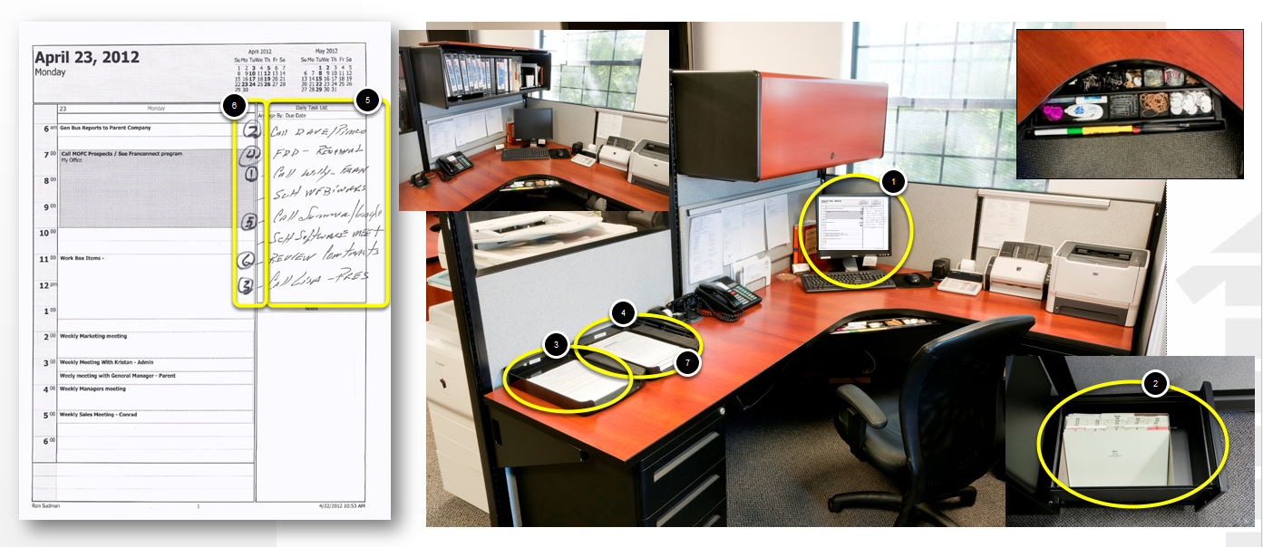
One Touch System
- Run out Outlook Calendar
- Pull items out of Tickler File
- Take items out of In Box
- Take items out of Work Box
- Write Out all Priority items combined from Tickler, Work Box & Inbox
- Prioritize your outlook 1-6
- Place all Combined Items in Work Box for the day. *(Any new Items will be placed in the Inbox and will wait to be addressed the following day)
Then, start with first item and go as far as you can go then either:
A) File it
B) Throw it away
C) Set up in tickler if you’re waiting for a call back
D) or Tickler it for a future date
Spending 15-20 min a day organizing your work for the day and week will keep you from feeling you don’t have enough time to get your work done and you won’t be overwhelmed.

Contributing Factors that Lead to feeling Overwhelmed
1. Doing things 3 times instead of once (Don’t cut corners and Do it right the first time )
2. Not following the system and doing things out of order and having to back track
3. Getting complaints due to not following systems
4. Team members not being considerate of other team players when they are out for the day and not calling in on time and being in the daily meeting. When this is not done pressure increases and complaints increase again taking up more time, thus making you feeling overwhelmed.
5. Not asking for managements help when you need it before you are drowning to guidance and assistance but not to do the actual work. (Use your life lines)

Training Tutorials

The First 100 Days for Property Inspector / Customer Service
Click Here to Download as a Checklist

The First 100 Days for Property Inspector - Customer Service


Testing
You will be tested and expected to know the procedures in all areas of maintenance and the steps involved in the various inspections you perform. While training, it is important that you take notes and ask questions as necessary.
Areas of testing will include but are not limited to proper procedures for:
Using your daily calendar
Using your tickler file
Proper flow of work station
Computer operation
Posting notices
Inspection Procedures
Walk through Procedures
Required Paperwork
Forms
Reports
Terminology
Repair Procedures
Time Frames for Completion
Tablet use

How to Create a New Job Estimate & Converting to Work Orders
Click here to Watch Video Tutorial; How to Create a New Job Estimate
Click here to Watch Video Tutorial; How to Transfer a Job Estimate to Work Orders

New Job Estimate from Command Center

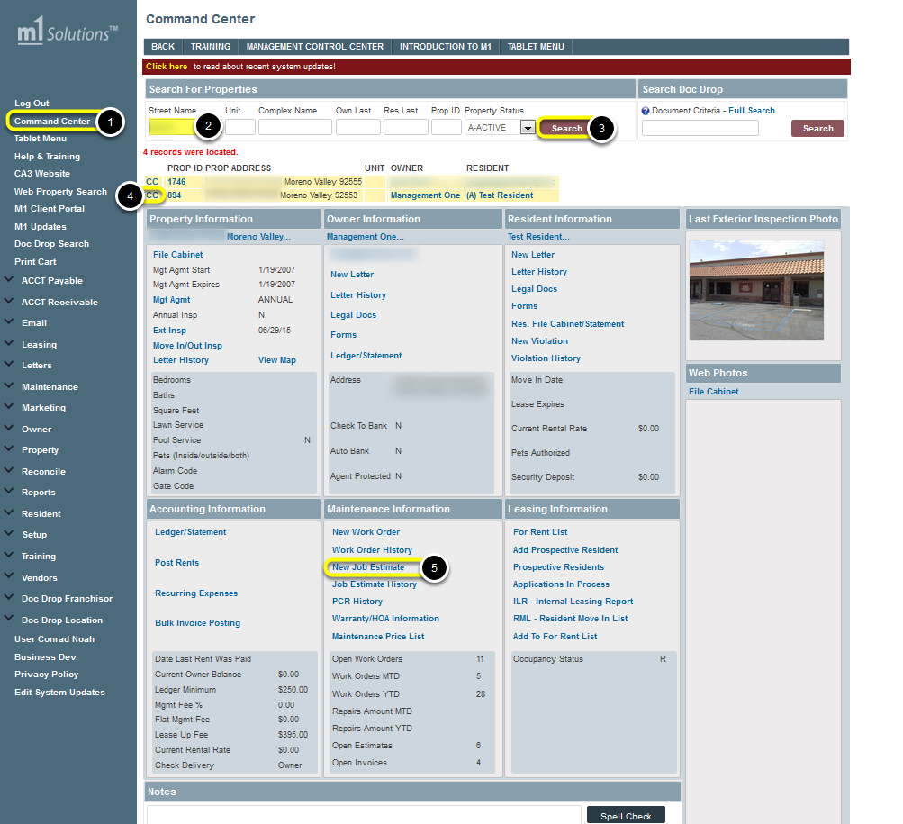
From the Command Center:
- Select Command Center from the Tree
- Enter in the Street Name for the Property
- Then Click SEARCH
- Select the CC link for the correct property (multiple properties may show up if they share the same street name)
- Click on the New Work Order link under Maintenance Information

Creating a New Job Estimate
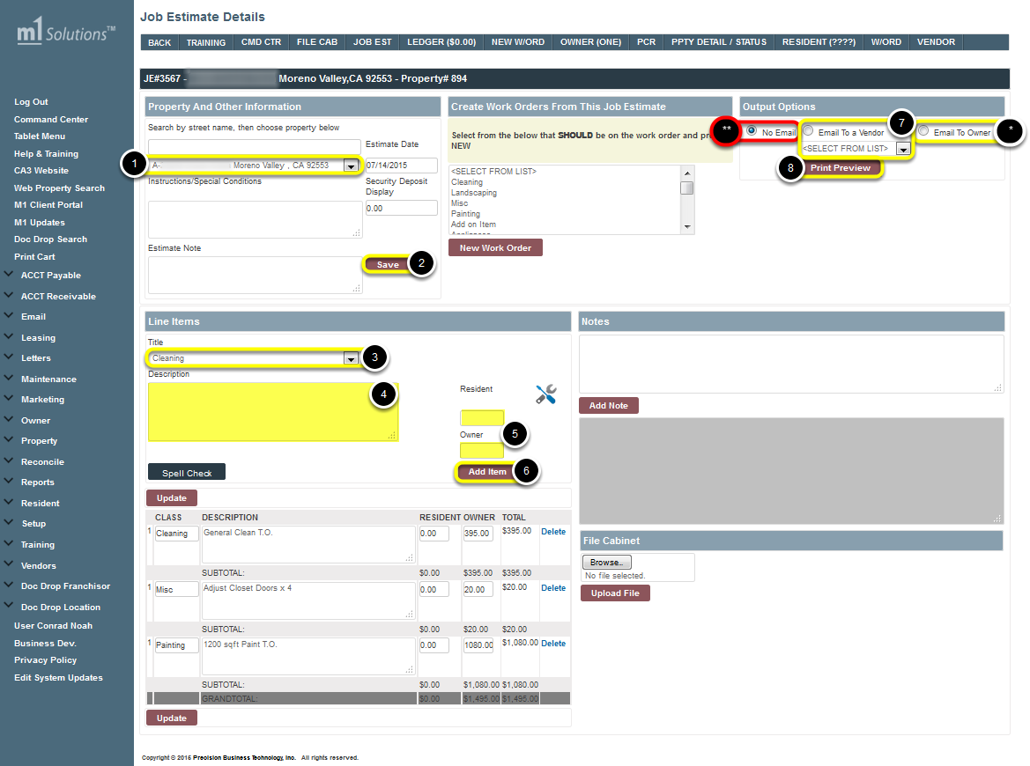
Click here to Watch Video Tutorial
- Verify the Property address is correct
- Then click SAVE
- Add line items by first selecting the Title category from the drop down menu under Line Items
- Enter in the brief Description of the repair needed
- Then determine the cost amount and enter it in the box for the appropriate party; either for the Owner or the Resident, or it can be a split amount for each. (If you do not have the price, you may skip this option at this time.)
- Then click ADD Item (continue this process for each item of repair needed)
- Email the the job estimate to a vendor by clicking on Email to a Vendor and selecting from the drop down menu, so they can review it and give a bid
- Then click Print Preview to complete the Job Estimate.
Note:
* You may also email a copy to the owner by check-marking Email to Owner before clicking Print Preview
** If you wish to print a hard copy, select No Email and click Print Preview.

Transferring the Job Estimate to Work Order(s)
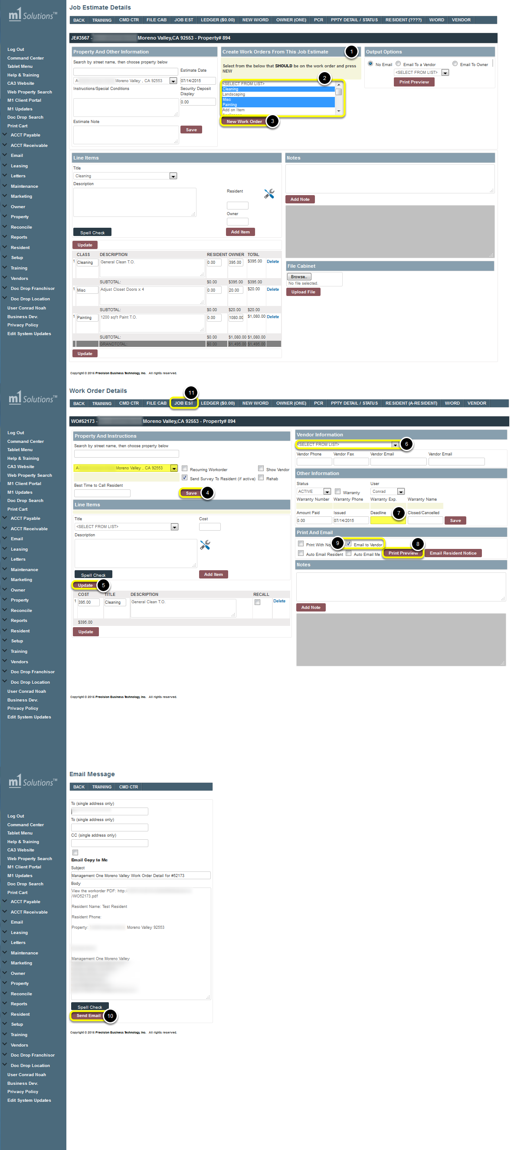
Click here to Watch Video Tutorial
- From the Job Estimate, Go to the top sections Create Work Orders From This Job Estimate
- Select the Title of repair(s) from the Scroll Down list, which you wish to transfer onto one work order (you can select multiple titles by holding down the Ctrl Button, on your keyboard, while selecting. Individual selections will issue individual work orders)
- Then click on NEW WORK ORDER
- Once you have been redirected to the Work Order Details screen, click SAVE to confirm the Work Order for that property address.
- Make any needed changes to the work order, if an item is not approved. Should any changes be made, click UPDATE to save all changes.
- Assign a Vendor from Vendor drop-down list
- Enter in a Deadline date, for the work to be completed by
- Then click PRINT PREVIEW, (a pop-up window will appear with a PDF file of the Work Order and you can print out for a hard copy)
- To email the Work Order to a vendor, check-mark Email to Vendor before selecting PRINT PREVIEW (this will not open a PDF pop-up for a hard copy print out).
- Continue to the next screen and click SEND EMAIL, to send the work order.
- Go back to the Job Estimate from the top bar link and continue this process for each work order title should multiple work orders need to be issued.

How to Create a New Work Order
Click here to Watch Video Tutorial
From the Command Center:
- Select Command Center from the Tree
- Enter in the Street Name for the Property
- Then Click SEARCH
- Select the CC link for the correct property (multiple properties may show up if they share the same street name)
- Click on the New Work Order link under Maintenance Information

New Work Order from Command Center
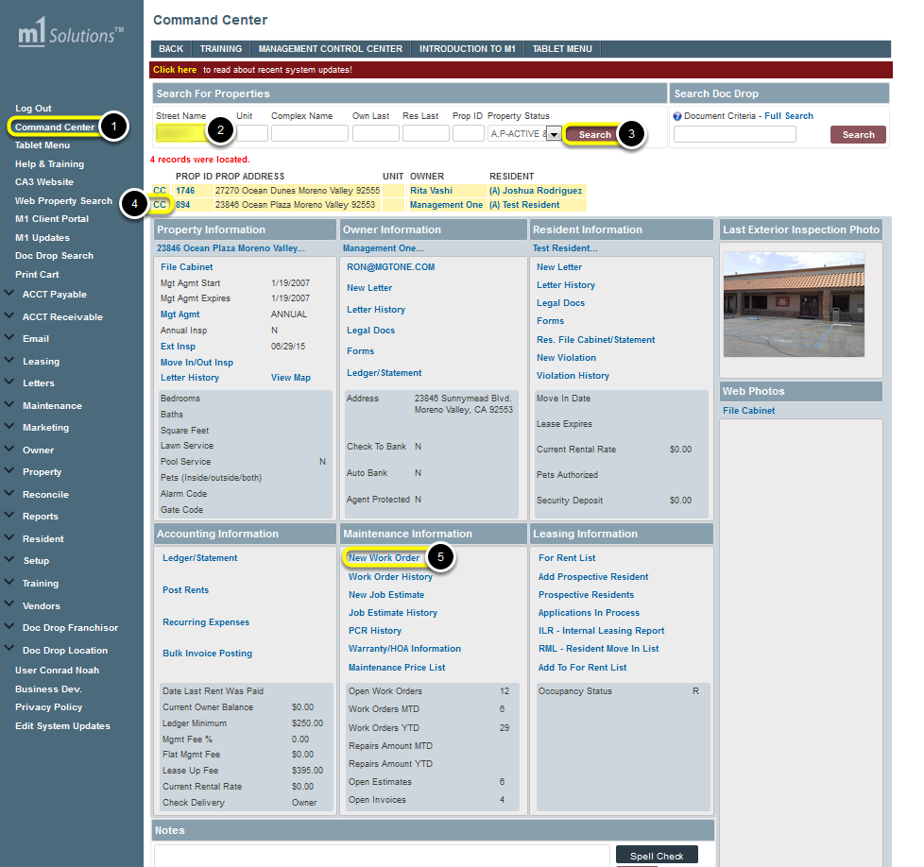

Creating and Issuing a New Work Order
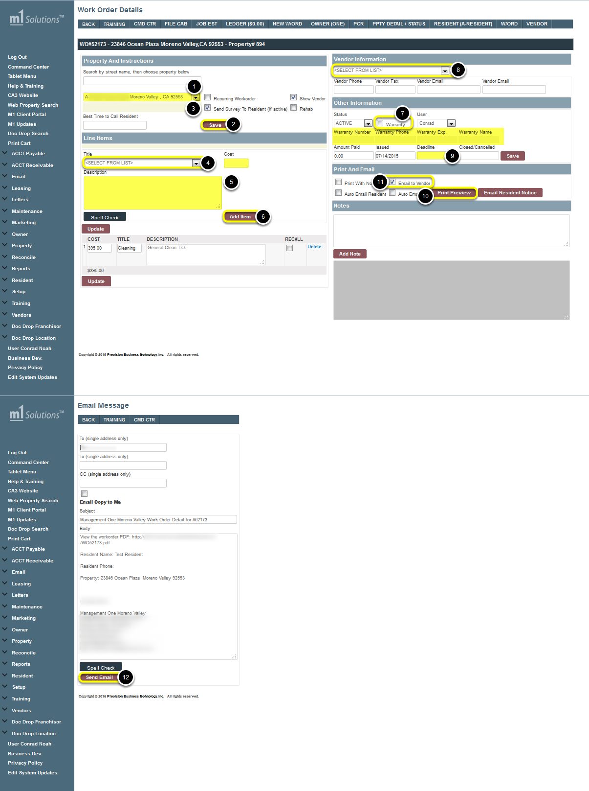
Click here to Watch Video Tutorial
- Confirm the proper Property address appears
- Then click SAVE
- Verify if there are any Special Conditions to be aware of before issuing the work order
- Select a Title for the needed maintenance item from the Scroll Down List
- Type in a brief Description of the repair needed (if you have a price, enter in the box to the right);
- Then click ADD ITEM
- Confirm if there is a Home Warranty before selecting a vendor; if so assign the Work Order to the Home Warranty Company from the Drop-down Vendor List (Warrantee information should be recorded in the Property Detail and will auto-populate in the Other Information section of the Work Order)
- Select Vendor from Drop-down list
- Enter a Deadline for the vendor to complete the job by
- Then click SAVE
- To email the Work Order to a vendor, check-mark Email to Vendor before selecting PRINT PREVIEW (this will not open a PDF pop-up for a hard copy print out).
- Continue to the next screen and click SEND EMAIL, to send the work order.
Note: If you have multiple items needed to be repaired; Repeat Steps 4-6 for each item to add them separately so appear as different line items.

Route Management
This function is used to better route your day in the field

Access Route Management
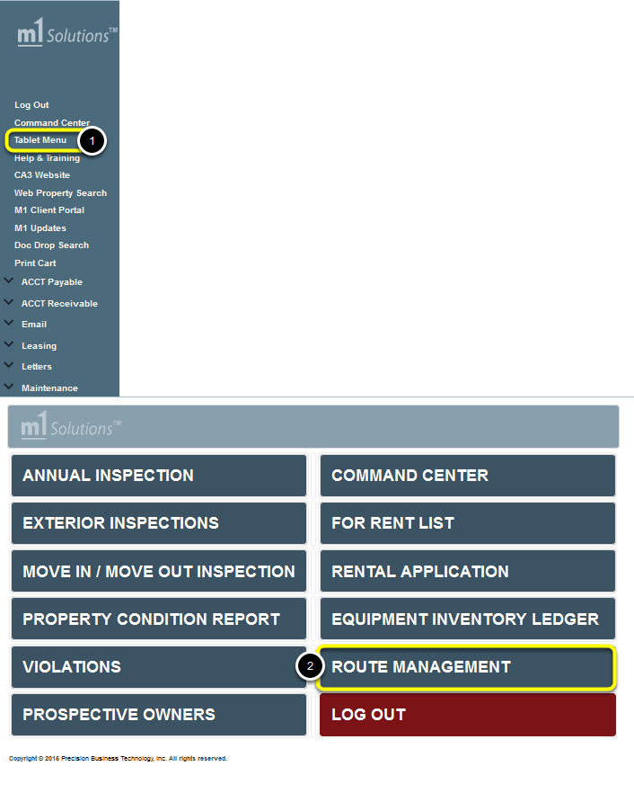
From the Tree View:
- Select Tablet Menu
- Select Route Management

Creating a Route List
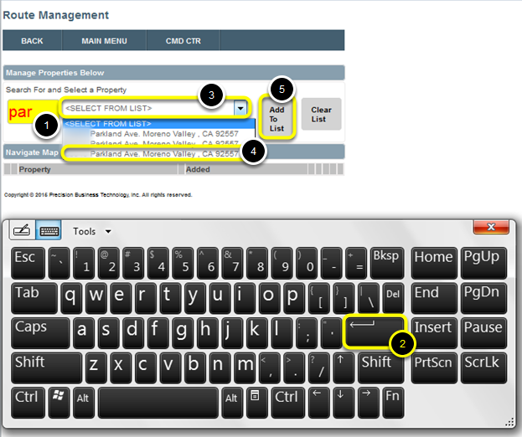
- Search for and select a property by typing the first few letters of the street name in the Yellow Box,
- Press ENTER on your qwerty/display keyboard
- Click on the Drop-down Menu
- Then select the appropriate Property from the Drop-down menu
- Click Add to List

Editing your Route
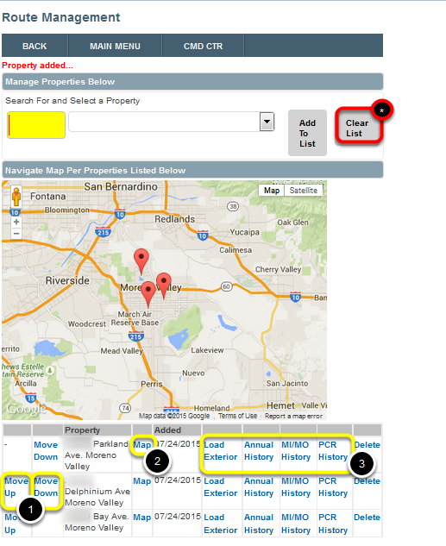
- Once all properties have been selected/added, they can Move Up or Move Down, by clicking on the links, to make your route flow more efficiently
- Click the Map link to open the property in your Tablet Map (then you can start your route guidance from your Current Location using GPS).
- The other inspection links are available at your convenience by clicking as needed to confirm the property condition on the last inspection(s)
Note:
* Once the inspections have been completed, Click Clear List to remove properties from the list

Annual Inspections
From the field while at the property

Accessing Annual Inspection Report on Tablet
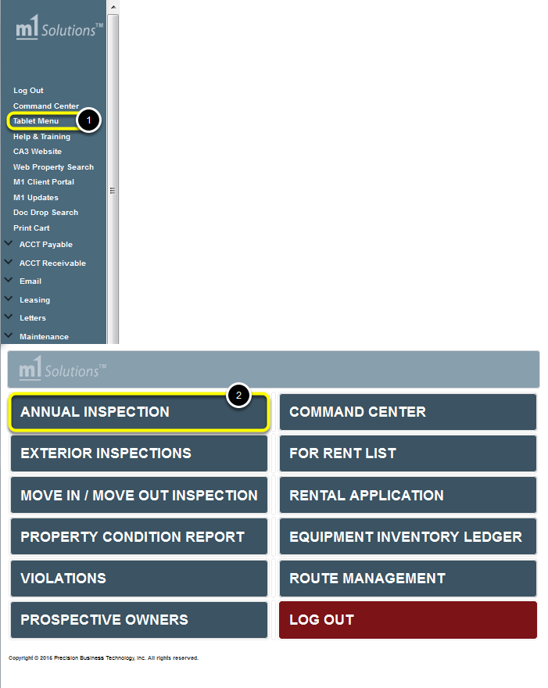
From the Tree View:
- Select Tablet Menu
- Select Annual Inspection

Create a New Annual Report
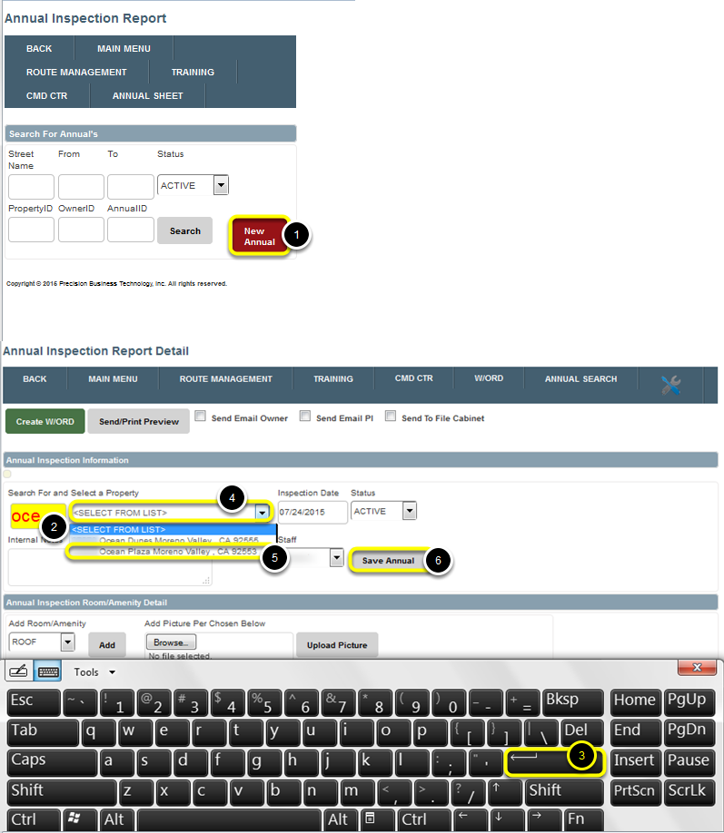
- Select New Annual
- Search for and select a property by typing the first few letters of the street name in the Yellow Box,
- Press ENTER on your qwerty/display keyboard
- Click on the Drop-down Menu
- Then select the appropriate Property from the Drop-down menu
- Click SAVE Annual

Filling out an Annual Report and adding Pictures during a Walk-through
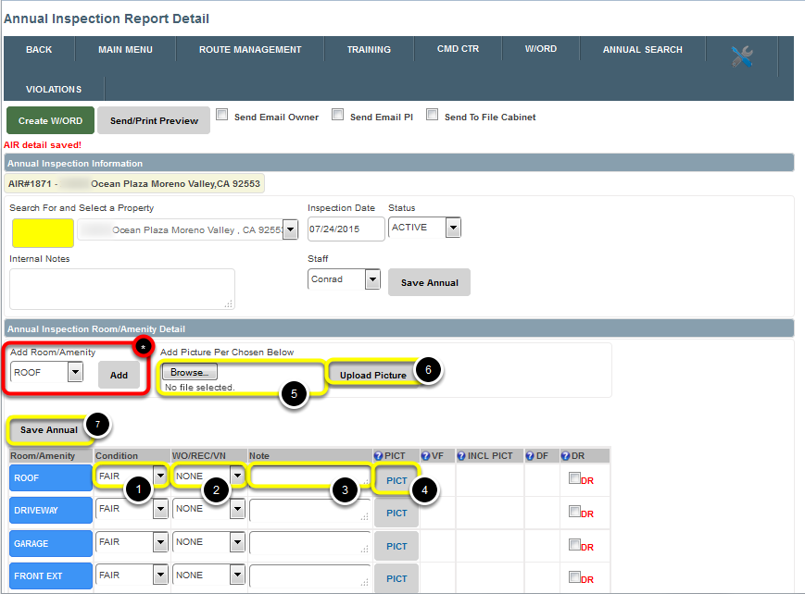
From the Annual Inspection Report Detail
- Continue down through each room and select the following Condition from the Drop-down List (Fair, Good, Poor or None)
- Select the type of item to be noted; either a Work order needs to be issued, a Recommended item is needed to be suggested to the owner or if a Violation needs to be issued
- Enter any Notes that may apply to the particular room/amenity
- To Add a Picture, if applicable, click on PICT for the item you want to add a picture for and you will be taken to the top of the screen.
- Click Add Picture Per Chosen Below (take a new picture or select from existing library)
- Click Upload Picture
- Click SAVE Annual
Note:
* Only one photo per line item may be added. Should additional photos be needed for a room, Add an additional room at the top of the amenity list)

Resident Signature for Annual Inspection
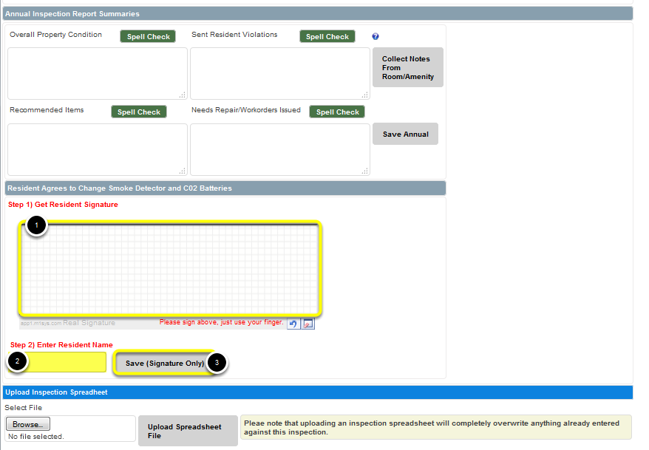
From the Annual Inspection Report Detail:
Once the walk through has been completed, you have the option of having the Resident Signature added; (this confirms that you’ve gone over the responsibility of the resident making sure the smoke detector and carbon monoxide batteries are changed on a regular basis and that all are currently operational).
To add a signature:
- Go to Step 1) Get Resident Signature and have the resident sign with their finger
- Click on Step 2) Enter Resident Name and type in their name
- Click SAVE (Signature Only)
This will complete the basic inspection while at the property.

Finalizing an Annual Report
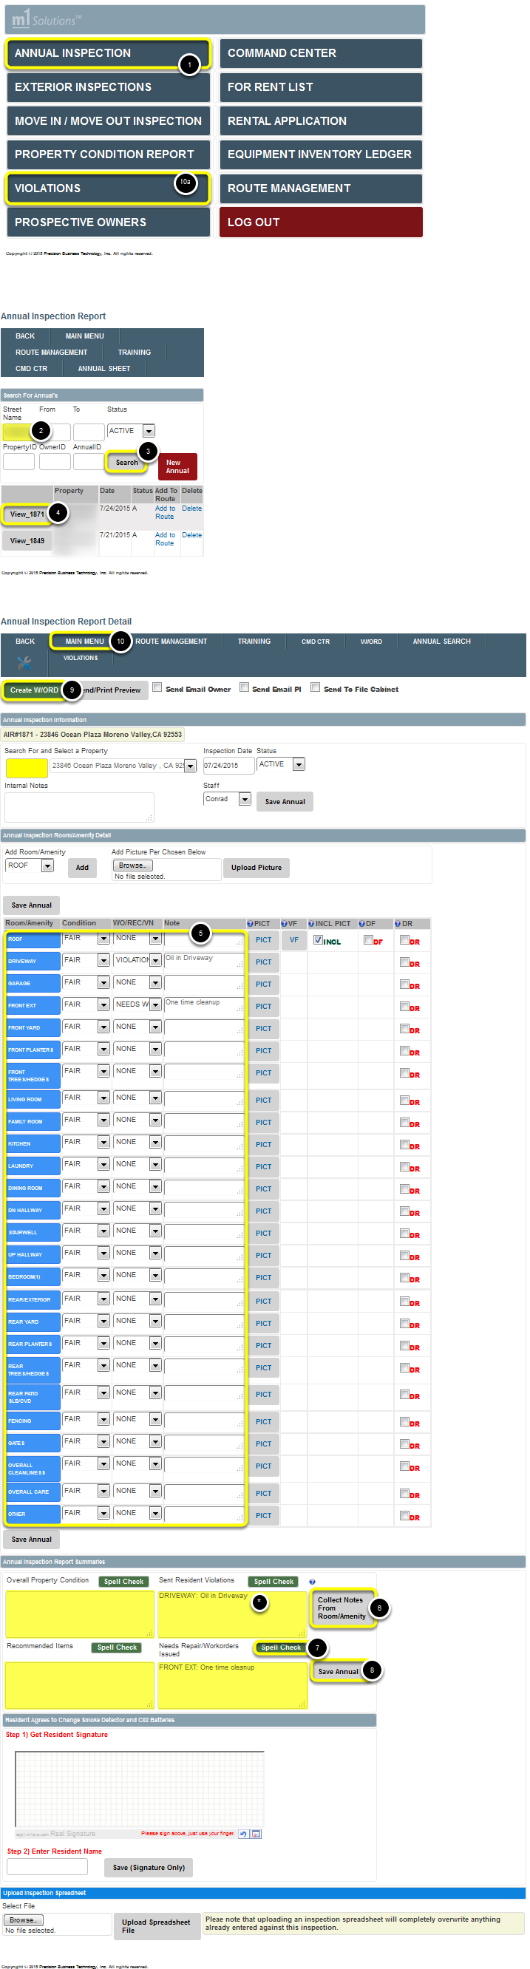
From the Tablet Menu:
After your appointment to finish up the report in the field. DO NOT finish in the office complete 100% so your mind is free of it before you go to another inspection of any kind.
- Click on ANNUAL INSPECTION
- Enter Street Name in Search Criteria
- Click Search to locate the inspection
- Click View for the inspection in question
- Review Each Room to verify all columns are filled out per Room/Amenity as needed
- Once all has been verified, click Collect Notes From Room/Amenity; (*) this will compile all notes from the above inspection and transfer to the appropriate sections.
- Click Spell Check as needed.
- Click SAVE Annual
- Should there be work orders needed click Create W/ORD at the top of screen; this will transfer all items in the Needs Repair/Work orders Issued section to a new work order. (Then complete the work order as needed, in the actual work order screen)
- If a violation is need, click Main Menu at the top bar then continue to a) Violations and issue as needed.

Sending an Annual Report to the Owner
This is only done after management has proofed it and then you can email it to the owner and place it in the annual file cabinet inside the M1 Software.
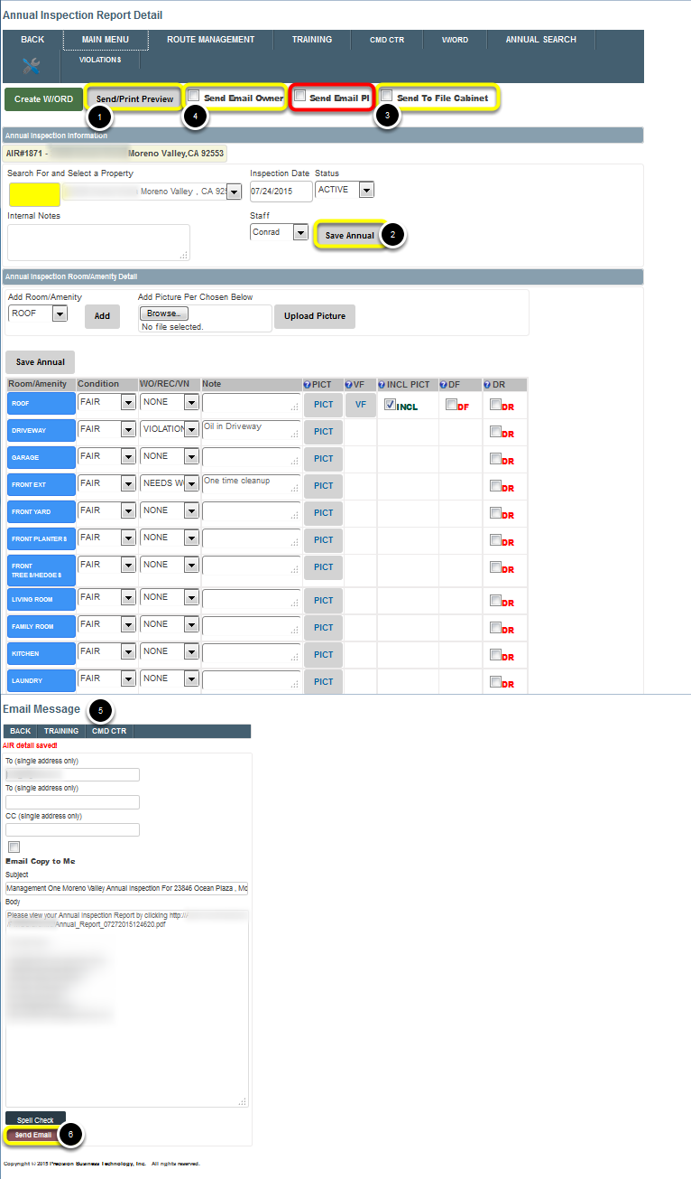
Once all items have been completed, Review the inspection report and save to the file cabinet before sending to the owner.
- To review the complete report, click Send/Print Preview. The report will appear as a PDF on the screen for your review. If any changes are needed, go back to the original inspection and edit as needed
- Then click Save Annual.
- Click Send to File Cabinet and click Send/Print Preview to save the report in the property file cabinet
- Click Send Email to Owner and click Send/Print Preview, if you wish to email the report to the owner
- This will frame out to the Email Message screen to continue to send
- Once the Send Email is selected, the report will be sent to the owner and a notation will automatically be entered in the property notepad that the inspection has been sent to the owner
Note:
This will automatically change the status of the annual from Active to Completed
This will automatically update the Annual Inspection report to show the inspection has been completed and not outstanding
If you wish to print a hardcopy, just click Send/Print Preview with not items to the right selected
If you wish to send a copy to the PI, if follow up is needed, then Click Send Email to PI and click Send/Print Preview

Property Inspector Van Set Up
This lists out the Components suggested for your Van and their Measurements, for How your Property Inspector Vehicle needs to be set up so you can work very effectively in the field
Click here to watch an Instructional Video
Click here to find out How to Install a Premier Sign Post

Shelf to Hold Spike
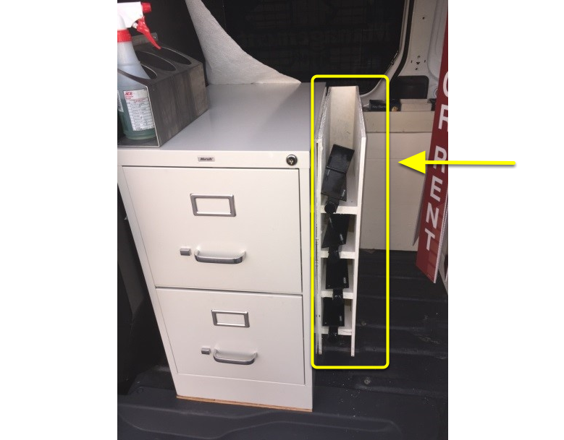
Shelf to hold spike
L = 24 in.
W= 4 ¼ in.
H = 27 ½ in.

"Ask Us" Ryder Tray
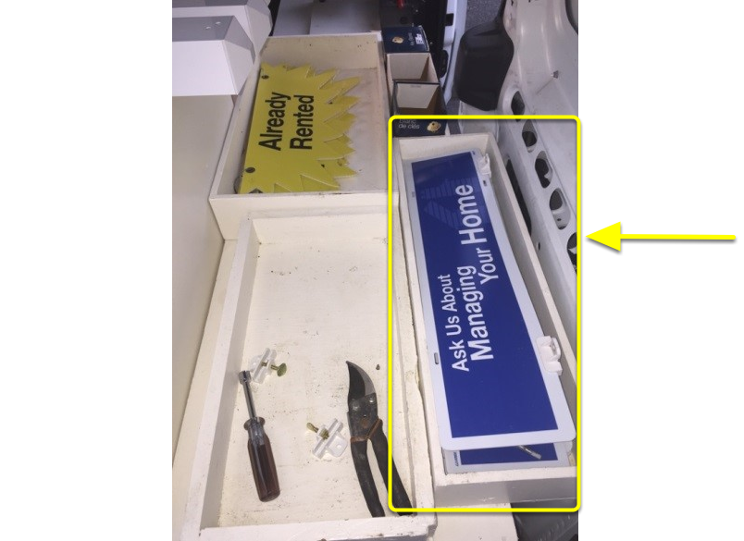
Ask Us Tray
L = 26 in.
W = 8 ½ in.
H = 4 in.

"Already Rented" Ryder Tray
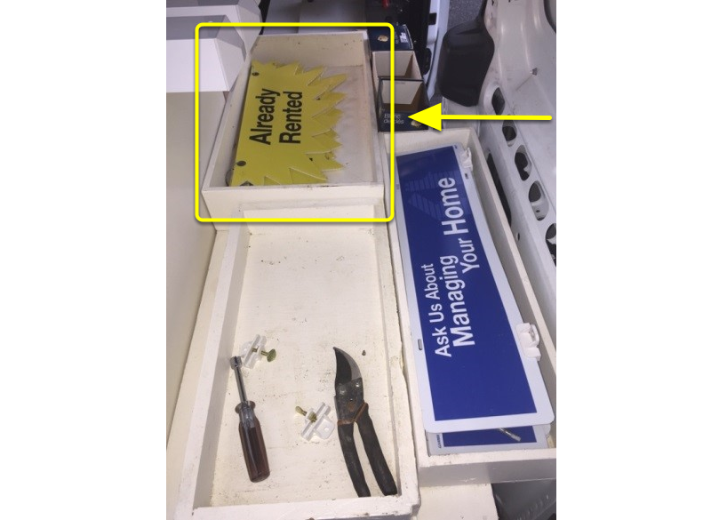
Already Rented Box
L = 27 in.
W = 12 in.
H = 4 in.

Sign Stand Box
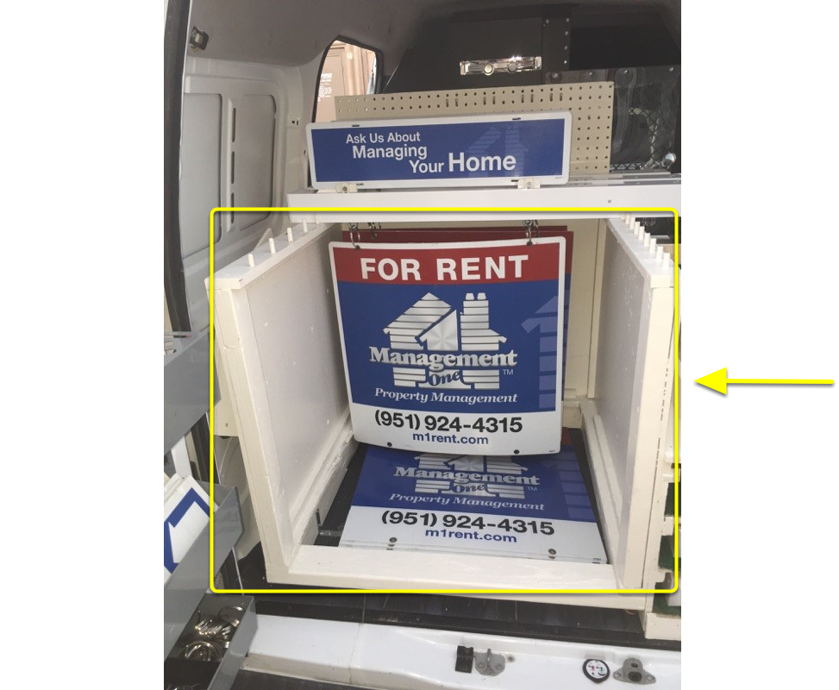
Sign Stand Box
Note: You will see a sign laying down, this is what NOT to do because will run the sign. Signs must stand up.
L = 32 in.
W = 30 in.
H = 30 in.

Key Machine Box Stand (It’s mandatory that you wear safety glasses, no exceptions)
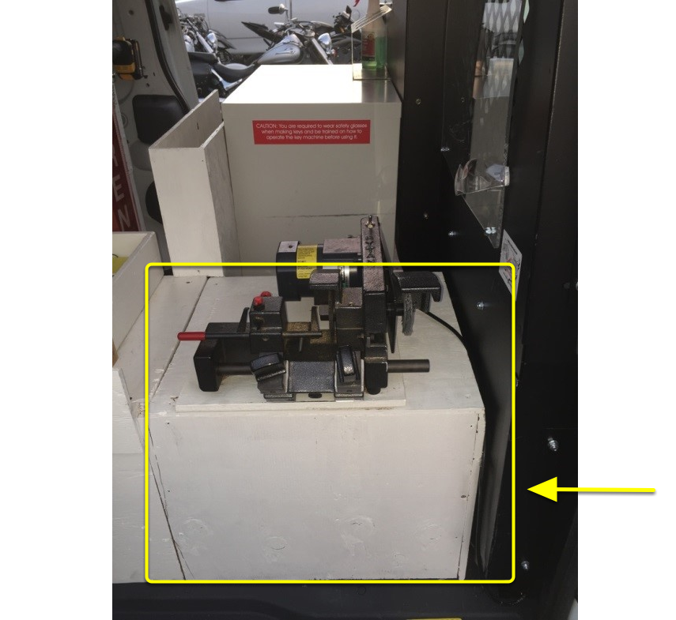
Key Machine Box Stand
L = 21 in.
W = 6 in.
H = 4 in.

Sign Post Cubbie
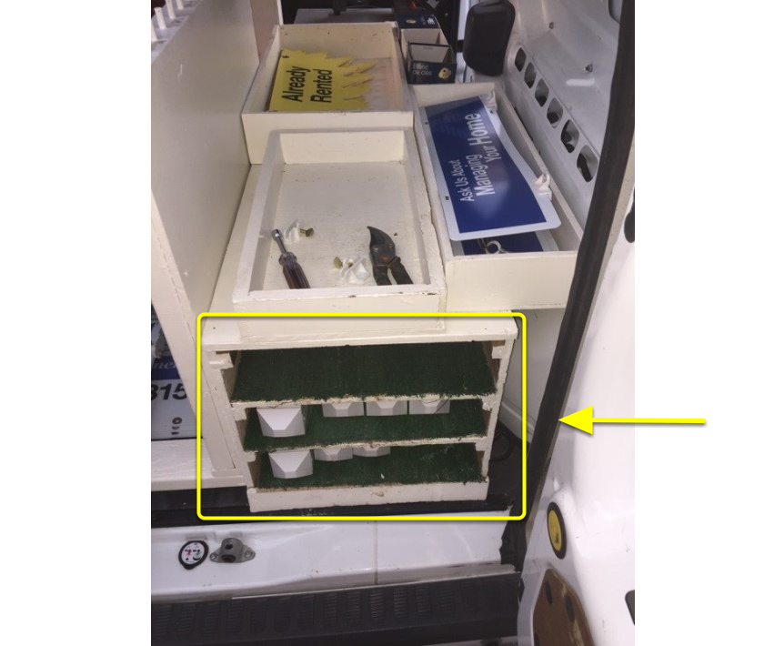
Sign Post Cubbie
L = 48 in.
W = 17 in.
H = 68 in.

Spare Parts Tray
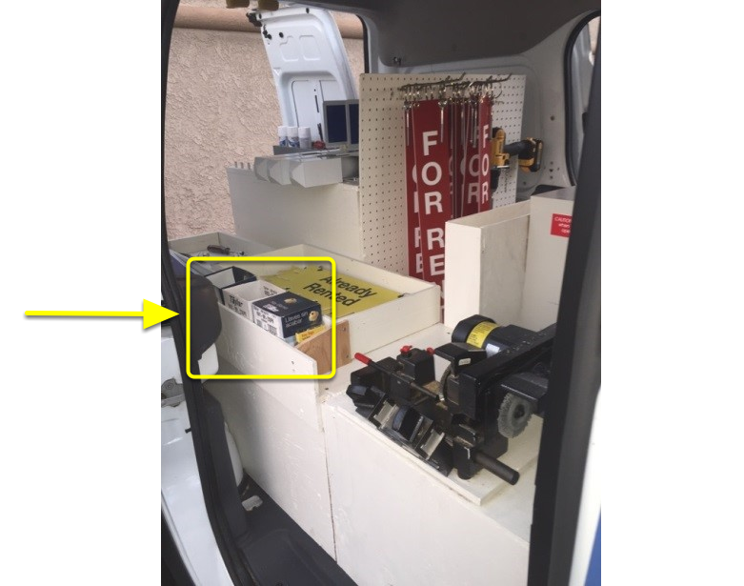
Spare Parts Tray
L = 27 ½ in.
W = 4 ¼ in.
H = 3 in.

Peg Board
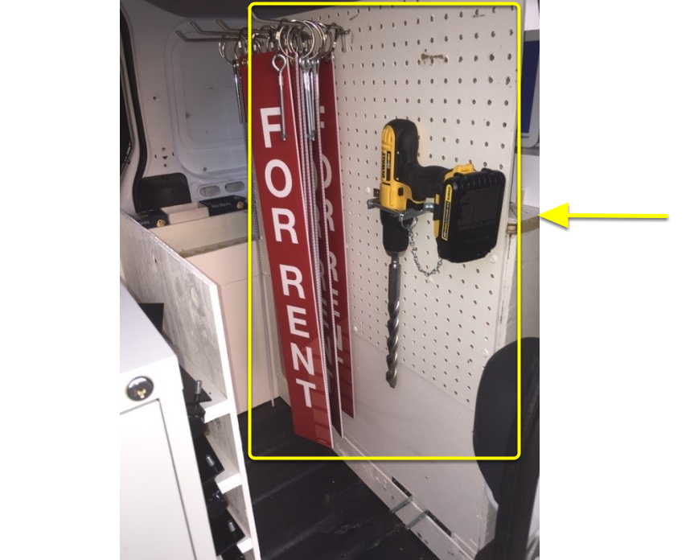
Peg board
For Rent Banners, Drill with bit and sledge Hammer which goes below drill bit in the 2 L Brackets, Sledge is not shown in picture.
You will notice that it has a pin that goes in front of the Drill and Sledge to hold them in place during transit.

Drill & Bit
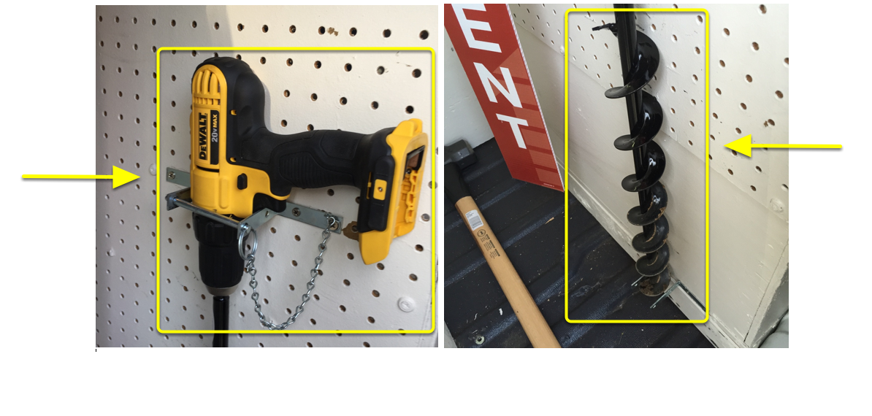
The Drill seen here can be acquired for between $140-$180 (DEWALT 20-Volt Max Lithium-Ion Cordless Compact Drill/Driver [Model # DCD780C2])
And the Auger Drill Bit for boring holes in all types of dirt, ranges from $40-$90 (The Auger Bit seen here is TANAKA Bulb Planting Auger Bit 2-Inch x 24-Inch [745204])

Passenger Seat Desk Setup
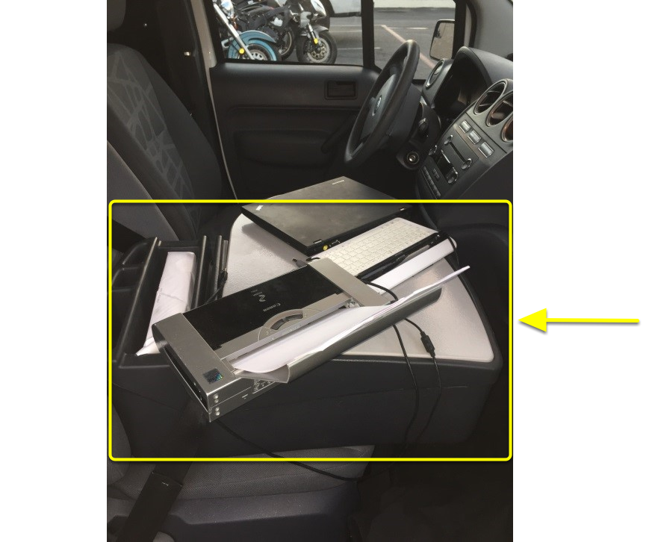

Printer and Keyboard Set up
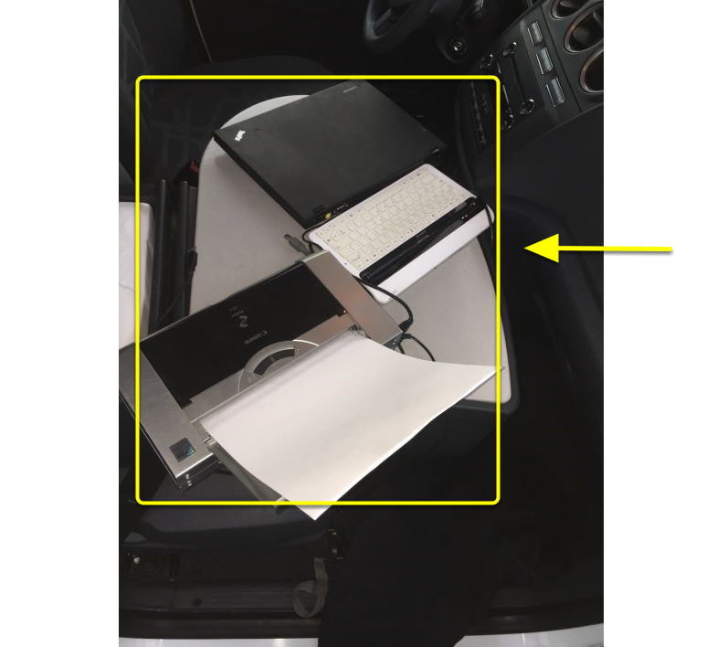
Office set up in Van Showing layout of Printer, tablet and laptop and desk

Training Process Videos

Maintenance Division Work Station
This is an overview of how the Work Station is Setup for the Maintenance Division using the Management One Licensed Operating System.

Video - Maintenance Division Work Station
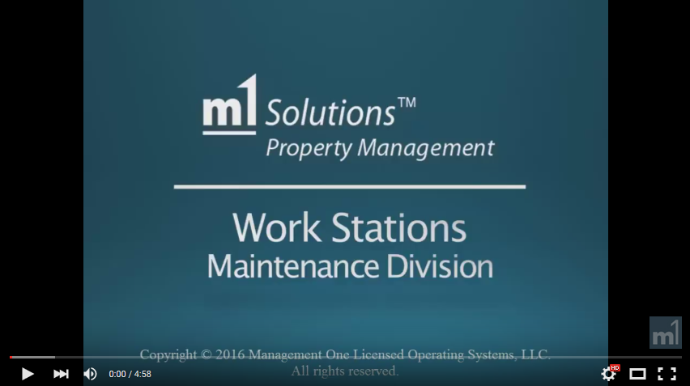
Click here to watch Video in a Browser

Tablet Menu Overview
This Video will introduce you to the Tablet Menu in the M1 Solutions Software and provides a general overview of the menu features and the pages they link to, accessing from the field any Reports, Forms and full blown M1 Solutions Software in the Cloud.

Tablet Menu Overview- Video
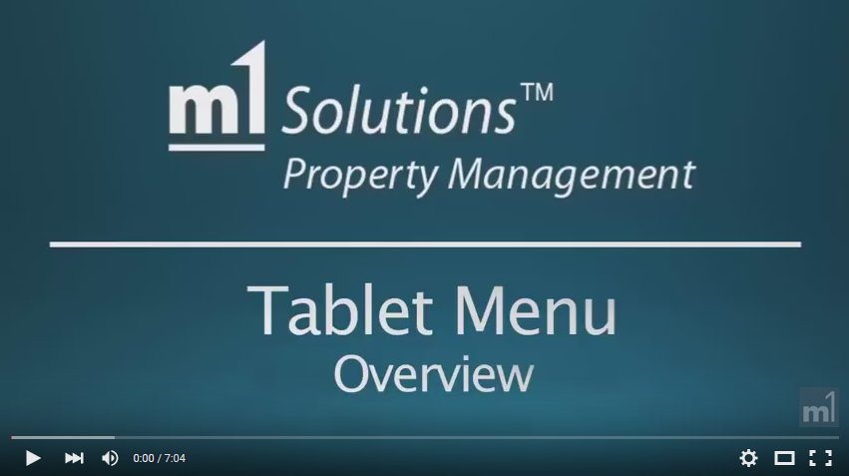

(PCR) Property Condition Report

Property Condition Report - Video
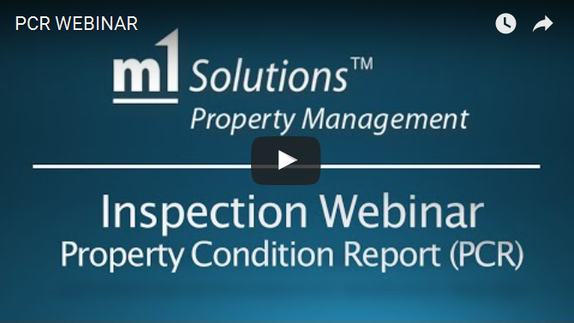
Click Here to Watch a Step-by-Step Tutorial Video

(FWT) First Walk Through Rehab Inspection Overview Process
This video walks you through what you will need to take to the field in preparation for the FWT inspection. It also shows you what takes place, on-site and live, as the Property Inspector inspects the property, what he takes care to notice and document, as well as how he documents each part of the FWT inspection process.

FWT Inspection Process - Video
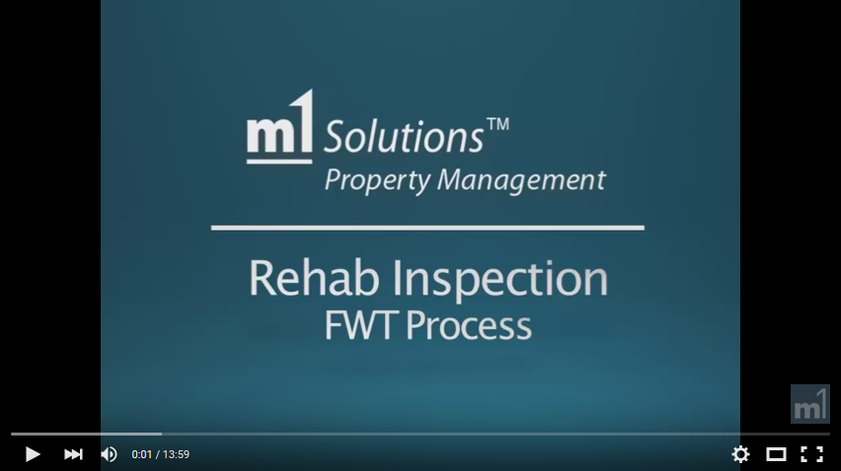

(FWT) How to Input Data for the First Walk Through in the M1 Solutions Software
This Video will show you how to Complete a First Walk Through (FWT) Rehab Inspection in between Residents, by filling out a Property Condition Report (PCR), including photos and video, in the M1 Solutions Software on a Tablet while walking the property in the field.

How to Complete a FWT Rehab Inspection - Video
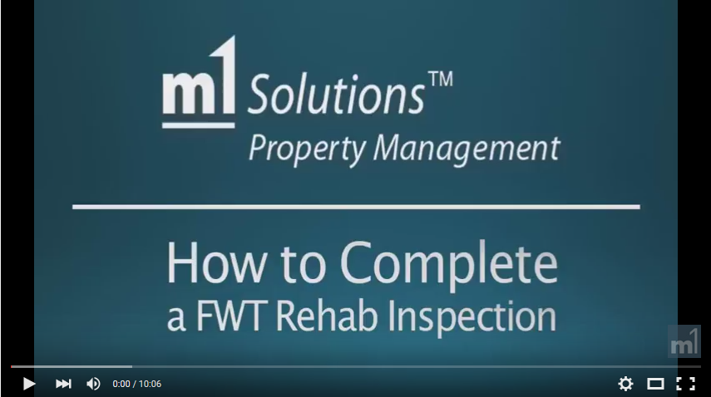

(FINAL) Final Walk Through Rehab Inspection Overview Process
This video walks you through what you will need to take to the field in preparation for the FINAL inspection. It also shows you what takes place, on-site and live, as the Property Inspector inspects the property, what he takes care to notice and document, as well as how he documents each part of the FINAL inspection process.

FINAL Walk Through - Inspection Process - Video
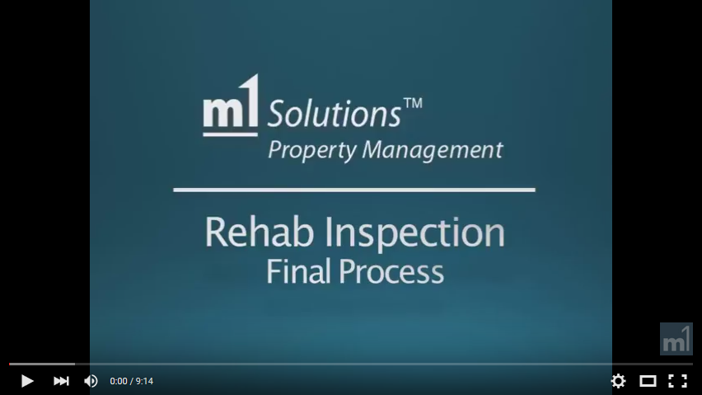

(FINAL) How to Input Data for the Final Walk Through in the M1 Solutions Software

How to Complete a Rehab FINAL Inspection - Video
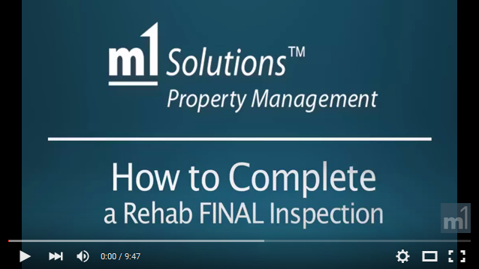

(RMO) Resident Move-out Inspection Overview Process
This video allows you to see how a Live Move-out Inspection takes place, between the Property Inspector and the Resident. You will notice how the Property Inspector takes care in addressing any concerns of the resident as well as how he properly disclosing any concerns the resident should take care to have, regarding the condition they plan to leave the property in when they finally move out and turn the keys into the Property Management company.

Move out Inspection Process - Video
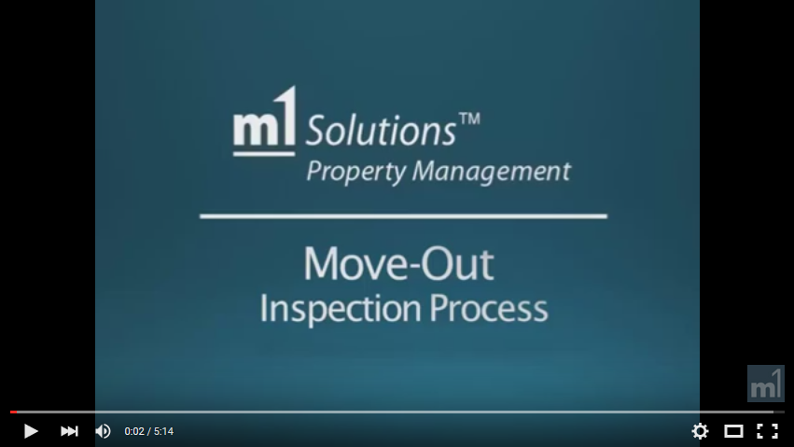

(RMI) Resident Move-In Inspection Overview Process
This video allows you to see how a Live Move-in Inspection takes place, between the Property Inspector and the Resident. You will notice how the Property Inspector takes care in addressing any concerns of the resident as well as how he properly disclosing how the workorders will be issued, how the resident should take care in the future, regarding the condition they plan to leave the property in when they finally move out and turn the keys into the Property Management company.

Move In Inspection Process - Video
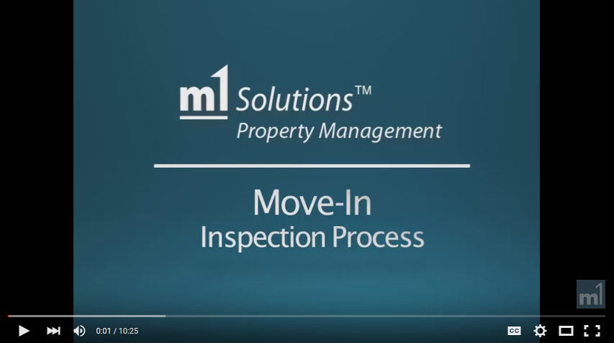

(RMI / RMO) How to Input Data for a Move-in / Move-out Inspection
This Video will show you how to Complete a Move-in or Move-out Inspection (as the Reporting Process is the same), by filling out the document on a tablet, including photos and issuing Work Orders, in the M1 Solutions Software on a Tablet while walking the property in the field.

How to Complete a Move-in or Move-out Inspection - Video
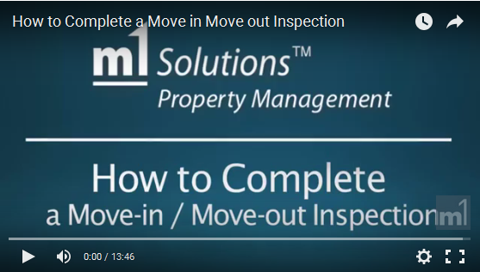

Move-in & Move-out Inspections

Inspection Webinar Move-in and Move-out Video
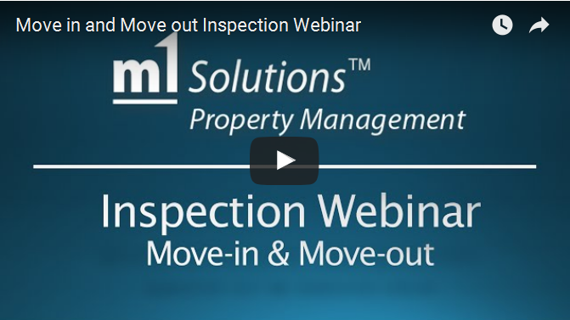
Click Here to Watch a Step-by-Step Tutorial Video

Exterior Inspection Overview Process
This video walks you through what you will need to take to the field in preparation for the Exterior inspection. It also shows you what takes place, on-site and live, as the Property Inspects the property, what he takes care to notice and document as well as how he completes Exterior inspection process.

Exterior Inspection Process - Video
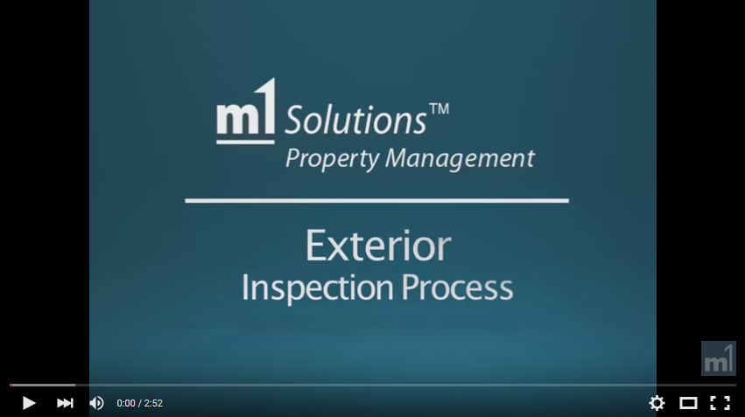

Exterior Inspection & Violation History Overview

Exterior Inspection & Violation History Overview - Video
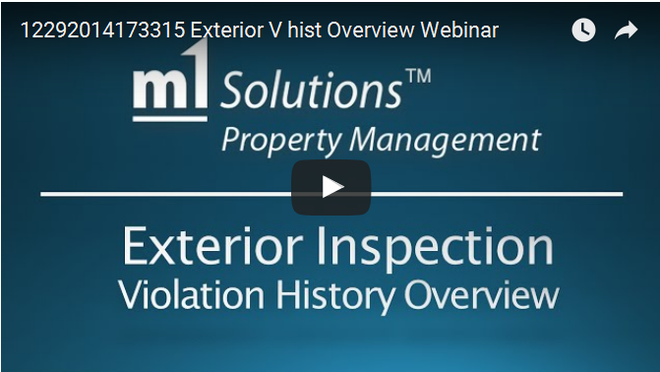
Click Here to Watch a Step-by-Step Tutorial Video

Exterior Inspection Tablet Overview

Exterior Overview - Video
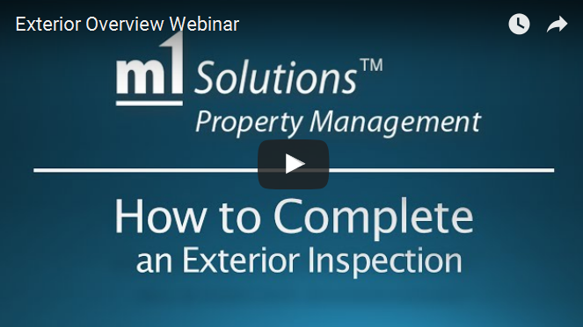
Click Here to Watch a Step-by-Step Tutorial Video

Annual Inspection Overview Process
This video walks you through what you will need to take to the field in preparation for the ANNUAL Inspection. It also shows you what takes place, on-site and live, as the Property Inspector walks the property, how he interacts with the Resident, what he takes care to notice and document and how he documents each part of the ANNUAL Inspection process.

Annual Inspection Process - Video
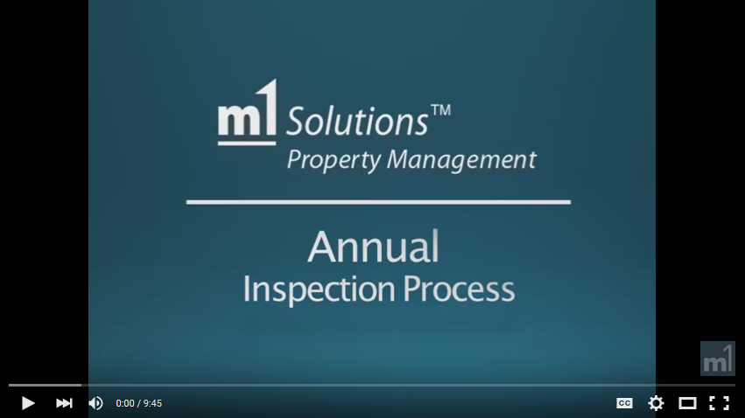

Annual Inspection Tablet Overview

Annual Inspection Overview - Video
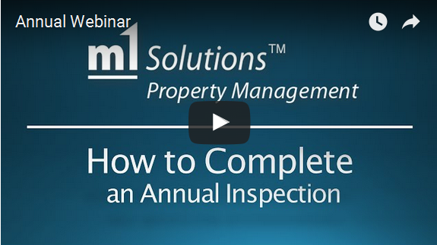
Click Here to Watch a Step-by-Step Tutorial Video

How to Input Data for the ANNUAL Inspection in the M1 Solutions Software

Annual Rehab Inspection - Video
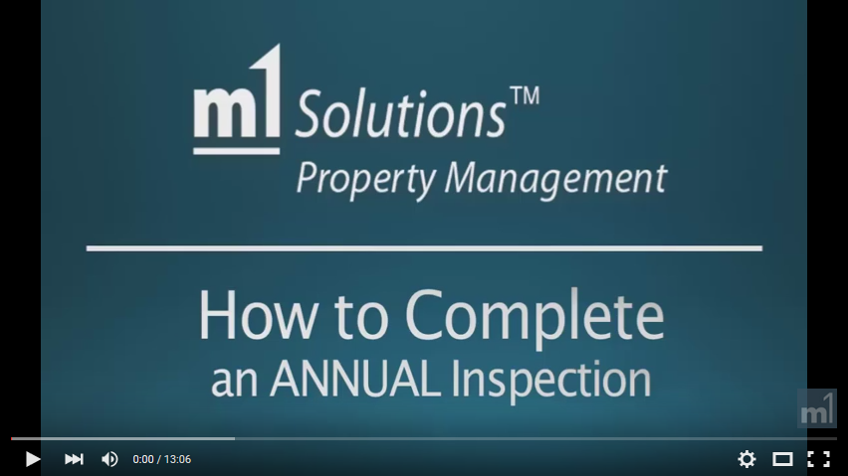

The Property Inspector Van & Its Components
In this Instructional Video you will be shown How your Property Inspector Vehicle needs to be set up so you can work very effectively in the field.
For Measurements of Component Part, Click Here

Video - PI Van and Its Components
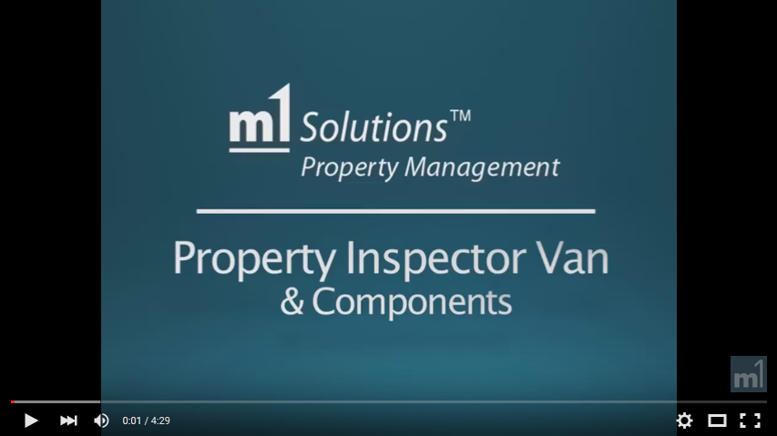
Click here to watch Video in a Browser

Van Supply List - Excel
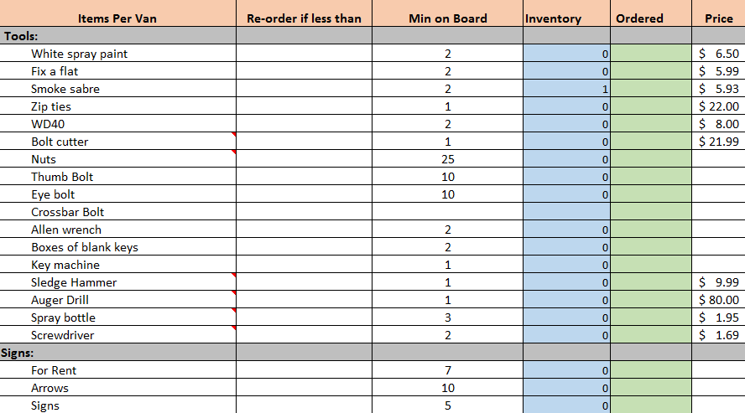
See Excel File for a full list of items needed, this must be turned in at the end of each month and video tape your van inside and out and send to management. Once a month you must restock your van so you never run out of things in the field as this is very costly to the company.

How to Install a Premier Sign Post from Lowen Sign Company
This Video shows how to Simply and Easily install a Premier Sign Post from Lowen Sign Company

How to Install a Sign Post Video
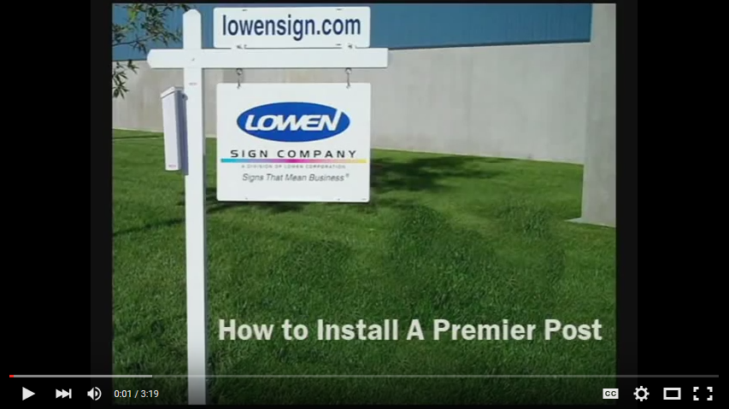

Work Order Management

Work Order Management - Video
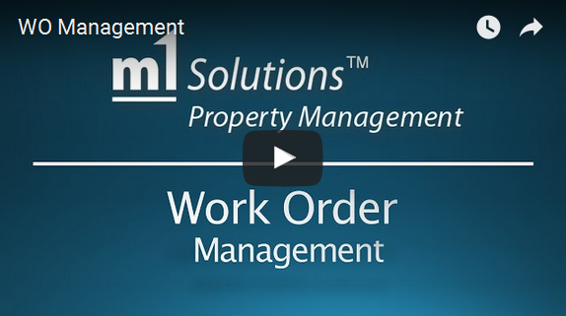
Click Here to Watch a Step-by-Step Tutorial Video

Work order management is worked from 7.45 - 8.25am every Monday, Wednesday and Friday.
You touch all work order in any stages every other day to make sure they are moving through the process.
A work order takes on many lives.
- Schedule work order
- Appt set on the work order
- Estimate given on work order
- Est approved on the work order
- Pending work order
- Invoice on the work order

Open work orders must be close and never go over 60 days
Estimates must never for over 30 days
Scheduling needs to be done under 7 days
Vendors need to call resident and schedule an appointment within 4 hrs

How to Create a New Work Order
How to Create a New Work Order in the M1 Solutions Software
Click Here to View a Step-by-Step Tutorial Article

How to Create a New Work Order - Video
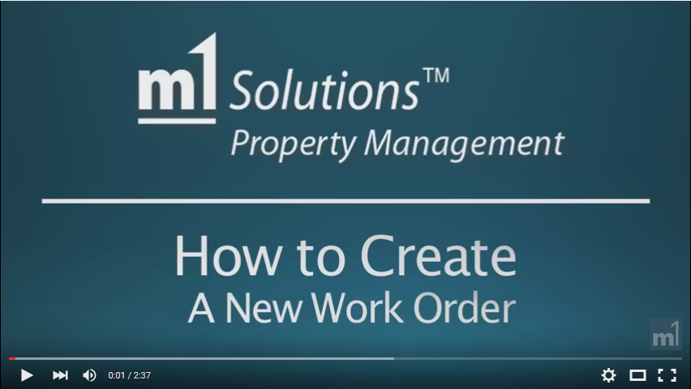
Click Here to Watch a Step-by-Step Tutorial Video

How to Create a New Job Estimate
How to Create a New Job Estimate in the M1 Solutions Software

How to Create a New Job Estimate - Video
Click Here to Watch a Step-by-Step Tutorial Video

How to Transfer the Job Estimate to Work Order
How to Transfer the Job Estimate to Work Order in the M1 Solutions Software
Click Here to View a Step-by-Step Tutorial Article

How to Transfer the Job Estimate to Work Order - Video
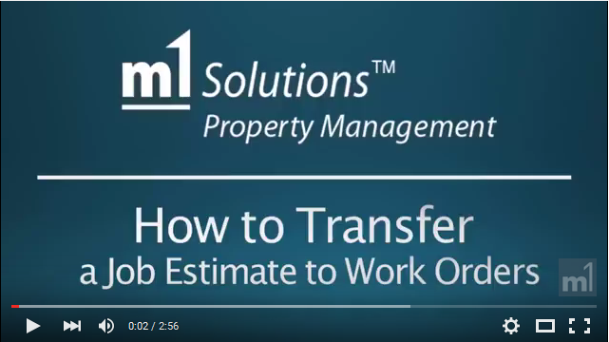
Click Here to Watch a Step-by-Step Tutorial Video

How to Review the Resident Move-in Ledger

How to Review the Resident Move-in Ledger- Video
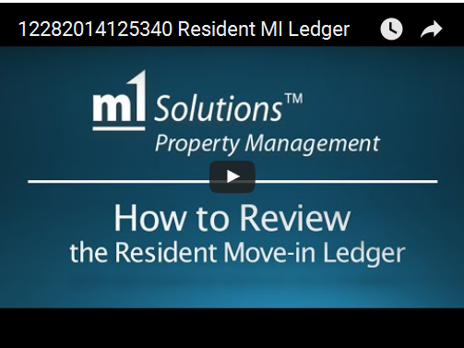
Click Here to Watch a Step-by-Step Tutorial Video

Yard Signs in the Property Inspector's Van
This video will provide you with an overview of how to set up your maintenance vehicle to accommodate the breakdown of parts for the Yard Signs, including Posts and Ryders.

Video - How to Set up Yard Signs in the Property Inspector's Van
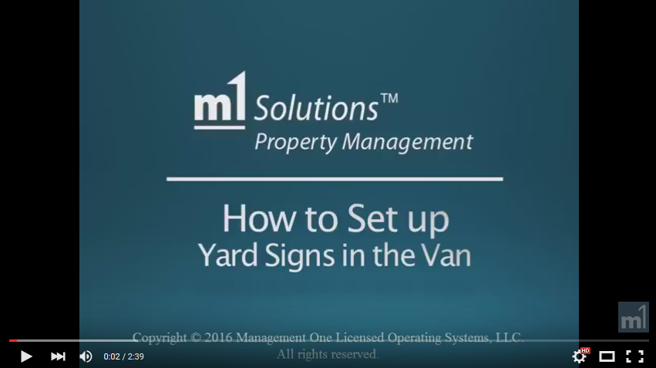
Click here to watch Video in a Browser

