**New Hire Checklist­­­­­­­­­­­­­­_________________________________________**

Date: ______________________

Employee: _______________________________________

Day 1

* Supply Employee Handbook and have necessary forms & handbook signed off
* Sign Real Estate License agreement (License to be held by Mgt One Broker)
* Make a copy of employee SS card and Driver’s License
* If selecting Direct Deposit, employee to furnish VOIDED check
* Set up M1 User login access
* Set up time card login access
* Set up email
* Supply training manual and training schedule to employee
* Supply most asked Q&A’s and schedule testing date
* Supply rental agreement and schedule testing date
* Supply management agreement and schedule testing date
* Go over Management One One-Touch System
* Go over daily hours including breaks, lunch hour, daily and weekly meetings
* Go over dress code
* Introduce to Management One personnel & tour of office
* Set up to watch videos – Maintenance and Phone Doctor

Day 2 – 5

* View how to use M1 Software (overview) video in M1
* View each webinar pertaining to division in M1
* View each video pertaining to division in M1
* View each quick start pertaining to division in M1
* Read over training manual
* Train on availability dates (17,15,12, 8)
* Train on LMS (leasing maintenance status)
* Train on Key Board
* Train on One Touch System
* Spend 20 minutes with manager at the end of day to review the day
* Confirm employee is taking notes and organizing them
* Provide Management One generic name badge

Day 5

* Fill out Hiring Evaluation form to confirm if employee will continue to 2nd week of employment (1st 2 weeks are temporary employment)

Day 6 – 10

* Spend 20 minutes with manager at the end of day to review the day
* Confirm employee is taking notes and organizing them
* Confirm employee has passed Q&A test for continued employment (this will show if they apply themselves)
* Fill out Hiring Evaluation form to confirm if employee will continue employment

Day 11 – 30

* Spend 20 minutes with manager at least 3 times a week to review training & questions
* Confirm employee is taking notes and organizing them (check weekly)
* Provide employee with office key
* Set up alarm code/access to office
* Order employee Management One name badge
* Confirm employee has passed rental agreement test
* Confirm employee has passed management agreement test

Day 30

* Complete Employee probationary review evaluation

Day 31 – 60

* Spend 20 minutes with manager at least 3 times a week to review training & questions
* Confirm employee is taking notes and organizing them (check weekly)
* Confirm employee has passed division test(s)

Day 60

* Complete Employee probationary review evaluation

Day 61 – 90

* Spend 20 minutes with manager at least 2 times a week to review training & questions
* Confirm employee is taking notes and organizing them (check weekly)

Day 90

* Provide self-evaluation form for employee to fill out
* Confirm typing speed has increased 10%
* Complete final Employee probationary review evaluation and go over possible salary increase, eligibility for bonuses, medical, retirement, etc.
* Order employee business cards (if applicable)
* Order name plate for cubicle (if applicable)
* Provide clothing allowance funds
* Personal development to start – provide journal and set out time

Day 91 – 180

* Spend 20 minutes with manager at least 1 time a week to review advanced training & questions

Day 180

* Provide self-evaluation form for employee to fill out
* Confirm typing speed has increased 10%
* Complete semi-annual review evaluation and go over possible salary increase

1 year

* Provide self-evaluation form for employee to fill out
* Complete annual review evaluation and go over possible salary increase

**First 5 Days Training Checklist­­­­­­­­­­­­­_______________________________**

Employee Name: ________________________________

Date: ______________

**Day 1**

Orientation paperwork, etc.

Watch Maintenance video

Watch Phone Doctor video

Read Training Manual in division

X____________________________ X ____________________________

  Employee Signature   Manager Signature

Date: ______________

**Day 2**

View how to use M1 Software (overview) video in M1

View each webinar pertaining to division in M1

View each video pertaining to division in M1

View each quick start pertaining to division in M1

Read over training again

Train on availability dates (17,15,12, 8)

Train on LMS (leasing maintenance status)

Train on Key Board

Train on One Touch System

Spend remaining time shadowing the person training them in that division

Spend 20 minutes with manager at the end of day to review the day

Confirm employee is taking notes and organizing them

Spend 30 min/day writing down notes on questions to ask the manager the next day

X_____________________________ X______________________________

  Employee Signature   Manager Signature

 Date: ______________

**Day 3**

View how to use M1 Software (overview) video in M1

View each webinar pertaining to division in M1

View each video pertaining to division in M1

View each quick start pertaining to division in M1

Read over training again

Train on availability dates (17,15,12, 8)

Train on LMS (leasing maintenance status)

Train on Key Board

Train on One Touch System

Spend remaining time shadowing the person training them in that division

Spend 20 minutes with manager at the end of day to review the day

Confirm employee is taking notes and organizing them

Spend 30 min/day writing down notes on questions to ask the manager the next day

X_____________________________ X______________________________

  Employee Signature   Manager Signature

Week 2 - 4

- Revert back to any training that you feel you need. This can be done from 9-10am or the best one-hour time frame that is best for that division. The rest of the time you will be training with the person who has been assigned to train you.

**Availability Dates/Rehab Process____________________________**

We calculate a Rehab process to submit to a 17 schedule to calculate Availability Dates for New Resident Move-ins; essentially we calculate backwards. *For example; if the property is ready for inspection on the 1st of the month we are saying the home will be ready to be occupied by the 17th of the month.*

**(Day 17-OCC)** This first phase being denoted as **“Occupied”** until inspected, the property inspector is given 2 days to schedule and inspect the property

**(Day 15-FWT)** By the 15th day away from availability, the property inspector should have completed his **“First Walk Through”** by inspecting the home and drawn up the estimate to give to a vendor; the vendor has one day to inspect and get it back to the Property inspector; confirming scope of work and prices (based on Mgt1’s set price list).

**(Day 12-WF)** By the 12th  day away from availability, the property inspector will send the estimate to the owner for their review and they will discuss the rehab and Mgt1 is considering we are **“Waiting for Funds”**;  essentially we are awaiting the decision of the owner to either send in Funds for the repairs or electing to complete the repairs on their own; if the owner elects to do the repairs themselves, they will sign a Rehab Agreement to commit to the same time frame of estimated completion; This way we all stay on schedule to make the home available on the same day that Leasing is marketing it for.

**(Day 8- WBD)** By 8 days away from completion, the funds should have been received which would allow for the work orders to have been issued and the Work should be in progress (**“Work Being Done”**). In this phase the M1 Contractor normally would have the work completed within 4-6 days; leaving enough time for the Property inspector to schedule and perform his Final Inspection, if all the work is complete, then he can video record the property; if there are a few minor items then there may be a day or two to complete them before moving a tenant in.

These dates should be checked daily by all staff in the following areas:

1. The (ILR) Internal Leasing Ledger

2. The (RML) Resident Move-in Ledger

3. The Key Board

__________________________________ ______________

Employee Signature Date



Keyboard System

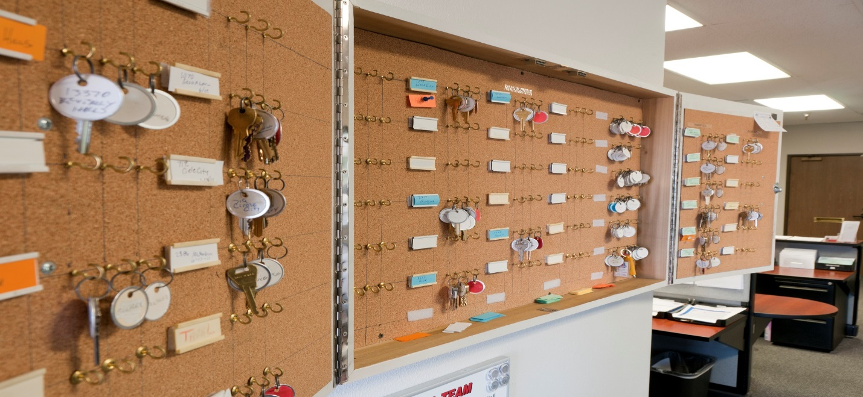

The keyboard is organized and segregated by 5 Colors and correlates directly with 3 reports; (ILR) Internal Leasing Report, (RML) Resident Move-in Ledger & the (COL) Close-Out Ledger; as well as denotes the current level of occupancy.

Orange – Owner occupied

Blue – Vacant

Green – Resident occupied

White – Rented / Waiting Move-in

Yellow – Closeout

There are only 4 statuses a property will be in, within our inventory

1. For Rent
2. Move-in
3. Rented
4. Closeout

*-The only time that a property is not on the keyboard is when it has been rented or is currently occupied*

***Keyboard Procedure***

*-Every property on the key board must have 3 key tags*

-New Accounts must have 3 sets of keys- if only 1 set is given, then there should be two tags which state “keys to be made” until they are made and hung on the keyboard.

-BOM Properties will have 1 set of keys (from the office filing cabinet) and the other 2 hooks will have key tags which note “Resident Occupied”.

-*Occupied status address labels will state the potential move-out / vacancy date*

-When a resident turns in all keys, the address tag and keys are not moved from “Green” to “Blue” until the Property inspector has walked the property and changes the (LMS) Leasing Maintenance Status on the (ILR) Internal Leasing Report, from “OCC” to “FWT”. The same goes for Owner occupied property; From “Orange” to “Blue”.

-When a property changes to (FWT) First Walk Thru status, one set of keys are taken off the key board and placed into a lock box which is left on the door knob of the rental property. This key hook is then marked with a “Red” key tag to note that a set of keys are in a lockbox at the property.

-If the owner or his vendor needs a set of keys, one will be taken off the board and replaced with a key tag that states “Owner” to note the owner has a key.

*-All keys must be signed out before released*

-If a key is taken off the board or checked out to a prospect by a staff member, the set of keys must be replaced with a key tag with notes the staff member’s “Name” who removed the keys.

*-Only keys for “Vacant” status properties can be checked out to prospective residents. All prospects must have been prescreened prior and must provide a photo id, give a deposit for the keys and sign the (AIS) Applicant Interview Sheet which states they are not taking possession of the home.*

-Any property on the board may change status to “White” once a Holding Agreement is signed with a new prospective resident and the property is considered Rented and waiting for Move-in. The vacancy date is then replaced with the projected Move-in date on the address label.

__________________________________ ______________

Employee Signature Date

**One Touch System_________________________________________**

1. Run out **Outlook Calendar**
2. Pull items out of **Tickler File**
3. Take items out of **Work Box**
4. Take items out of **in Box**
5. **Prioritize** all items in work box
6. Prioritize your Outlook with top 1-6 items
7. Start with first item and go as far as you can go then either:

A) File it

B) Throw it away

C) Set up in tickler if you’re waiting for a call back

D) Tickler it for a future date

Spending 15-20 minutes a day organizing your work for the day and week will keep you from feeling like you don’t have enough time to get your work done and you won’t be overwhelmed.

Things that create you feeling overwhelmed:

1. Doing things 3 times instead of once (Don’t cut corners and follow the system the first time)

2. Not following the system and doing things out of order and having to back track

3. Getting complaints due to not following systems

4. Team members not being considerate of other team players when they are out for the day and not calling in on time and being in the daily meeting. When this is not done, pressure increases and complaints increase again taking up more time, thus making you feeling overwhelmed.

5. Not asking for management assistance when you need it when getting behind before you are drowning. This is for guidance and assistance but not to do the actual work. (Use your life lines)

__________________________________ ______________

*Employee Signature Date*

**Hiring Evaluation__________________________________________**

Employee:

Hire Date:

1. Are they taking notes in detail? (On a scale of 1-10- 10 being highest)

1. Are the following verbal instructions and did you write down what you ask the staff and what and did they respond on time and thoroughly?

1. How many verbal instructions did you give the staff member?

1. Are they following written instructions and did the staff respond on time and thoroughly?

A) How many written instructions did you give the staff member?

1. Are the comprehending (On a scale of 1-10- 10 being highest)

A) How many times do you have to tell them the same thing before they get it?

1. Are they retaining on at least 3 items each week during the first two weeks?

1. Do they show up ahead of time, on time or late?

1. Are they proactive or reactive?

9. Would you continue with them if you were paying the bills and it was your company?

If you would or would not, explain why?

1. Did they pass the Q&A test? (minimum of 90% required) Score:

Other comments:

**Training Performance______________________________________**

Employee:

Process to be Trained on:

Tasks & Duties to Perform:

Start Date:

Deadline:      Was deadline met? Yes/No

Issues to Correct:

Did they take notes on this process? Yes / No

Did they have to ask for help? Yes / No How many times?

Did they question the process? Yes / No How many times?

Did they ask “Why do you do that?” or “How do you do that?”

When asking a question, do they use “you guys” or “we” when referring to Mgt1?

Trainer Critique:

**Employee Self Evaluation___________________________________**

Date:

**Employee’s Name:**

List areas in which you feel you meet or exceed position requirements and/or previous year’s goals.

What would assist you in enhancing your performance or meeting your goals?

**PROFESSIONAL DEVELOPMENT.** Training, conferences, seminars, and workshops attended by employee in current performance period. Recognition or awards nominated for or received. Job-related licenses or certifications obtained or held. Job-related committee participation during this evaluation period.

List job-related goals for the next evaluation period. Explain how these goals can be achieved.

1.

2.

3.

**Compensation-**What do you feel is warranted and why?

**GOAL SETTING -- Employee and Supervisor complete this section together**

**Performance Evaluation____________________________________**

**Date:**

**Employee:**

**Position:**

**Type of Evaluation:** 90 day / 180 day / Annual

On a scale of 1-10 with 1 being lowest and 10 being highest, rate the employee on each item. Include any notes that may be pertinent to the item being rated.

**Attention to detail:**

Notes:

**Ability to retain:**

Notes:

**Ability to follow verbal instructions:**

Notes:

**Ability to follow written instructions:**

Notes:

**Ability to multi-task:**

Notes:

**Speed to complete their workload/tasks:**

Notes:

**Overall attitude:**

Notes:

**Are they on time for deadlines:**

Notes:

**Are they a team player:**

Notes:

**Task management ability-do they prioritize their work:**

Notes:

**Are they more proactive or reactive:**

Notes:

Total Scored:

**Review Evaluation_________________________________________**

Employee Name:       Supervisor Name:       Date:

**Current review Notes & Objectives**

**review Results**

**Business Development Action Staff to take**  **By When**

|  |  |
| --- | --- |
|  |  |

**Action Steps By Coach to take By When**

|  |  |
| --- | --- |
|  |  |

**Pay Increase**

Base increase: $       Effective:

Bonus:       Effective:

**other notes**

**Next Review Date:**

____________________________________ ___________________________________

Employee signature Manager signature