Copyright © 2016 Management One Licensed Operating Systems, LLC. All rights reserved.

Management One Licensed Operating Systems

Applications Leasing Test

2016

**Leasing Applications Test__________________________**

Name:       (For manager use only) Results: _____________

Date:

[Fill out the answers to the best of your knowledge]

**Applications & Qualifying**

1. After taking an application, what are the procedures to take before running the application?

a.

b.

c.

1. If an applicant has a mortgage payment on their credit report and their home is being rented, what are the procedures to take?

1. If an applicant is self-employed, what will you need to verify employment?

1. How many judgments/public records can an applicant have before being denied?

1. What does it mean if the judgment has been released? Does the Judgment still count?

1. How many times may an applicant be late in 1 year before they are denied?

1. If an applicant needs to bring in information for his application, how long should you give him/her to bring it in?

1. After running a credit report, you figure out the schedule estimated payments, what should you now compare this against?

1. After qualifying an applicant what are the steps to take?

a.

b.

c.

d.

e.

1. See form “A” to figure out the debt to ratio, would these residents qualify?

1. After a resident qualifies, how much time do they have to bring in a holding deposit?

**Holding & Security Deposits**

1. Before typing up a lease, it is important to fill out what form?

1. If a resident has a pet, what do you add the Pet Deposit to?

1. After a resident has come into sign a holding deposit, what 4 steps do you now take?

a.

b.

c.

d.

1. What 3 things go into preparing a lease package?

a.

b.

c.

1. After a resident has signed a lease, what steps do you take?

a.

b.

c.

d.

1. If a resident signs a Holding Deposit & Security Deposit at the same time, what do you do?

1. A new resident calls you and wants to move in early, what do you tell them?

1. If an owner calls to gather information regarding their new residents, what information can we divulge?

What can we not divulge?

**Leasing Applications Test-Answers__________________**

1.

a. Prepare application process check list and application evaluation sheet. Review application making sure all information has been provided for all applicants 18+ and (# of occupants, ages, pets, etc).

b. Confirm app fees have been paid for all applicants 18 and over.

c. Gather all documents needed from all applicants (IDs, social security cards, 4 pay stubs).

2. The mortgage payment will be included in their debt. Get a copy of the rental agreement from applicant showing they are renting their property out. Count the rental amount in their income.

3. Business license or tax forms with information.

4. Two

5. Applicant has satisfied judgment. Don’t count as negative or positive.

6. 4

7. 24 hours

8. Income

9. Contact applicant to schedule holding. Prepare holding packet.

10. Debt on credit report plus 1 month’s rent divided by income

11. 24 hours

12. Rental Agreement Checklist

13. Security Deposit

14. Holding deposit given to accounting, update ILR/RML, prepare lease and have management proof it, schedule lease signing appt.

15. Execute Lease Agreement Checklist, prepare lease agreement, prepare celebration bag.

16. Security deposit is given to accounting, completed items checklist (utility form received, etc.), update RML, copy rental agreement attach to packet and give to accounting.

17. Prepare a receipt give copies to resident and give to accounting.

18. Depends on the status of the property and you will check and get back to them.

19. I can tell them how many occupants only (family with children or not), if they have pets, field of work, and that they went thru our stringent qualifications and are backed by our eviction guarantee and qualified. We cannot mention race, where they work, and their contact information.

**Form A**

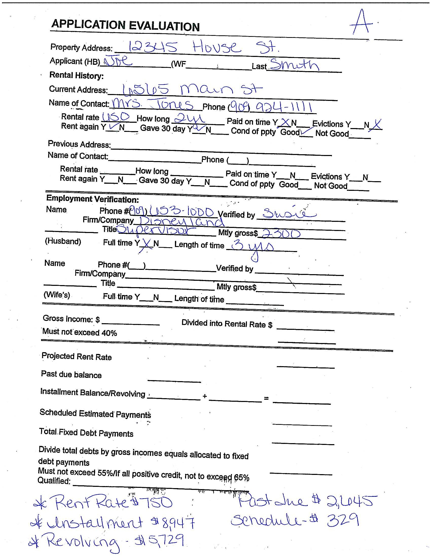

**Form B**

