Copyright © 2016 Management One Licensed Operating Systems, LLC. All rights reserved.

Management One Licensed Operating Systems

Knowledge Based Manual

FAQ- Frequently Asked Maintenance Questions and Answers

2016

Contents

FAQ- Frequently Asked Maintenance Questions and Answers 2

Quick Reference Flip Chart 2

Rehab 3

Rehab Work/Repairs 3

Funds 4

Annuals 5

General Maintenance 5

Pool Service 6

Videos 7

FAQ- Frequently Asked Maintenance Questions and Answers

[Click Here to Download MS Word .docx file](http://app1.m1sys.com/PMOS/systemdocs/Maintenance%20Flip%20Chart%20Q%20&%20A.docx)

Quick Reference Flip Chart

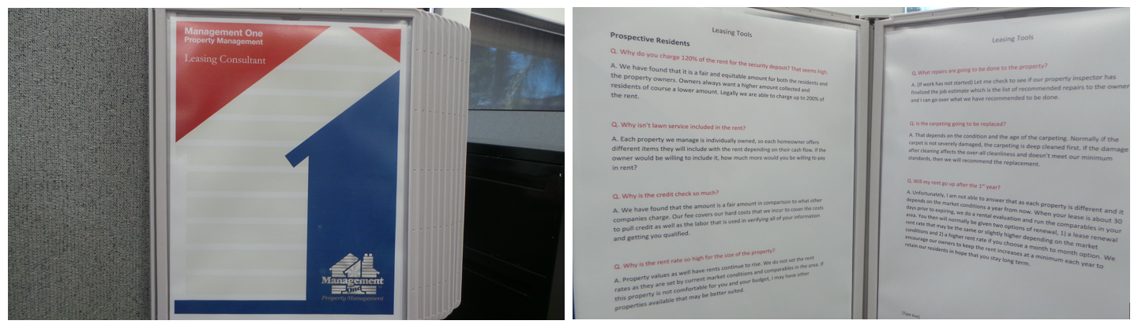

It is recommended that the following Frequently Asked Questions are printed and displayed in a Hanging Flip Chart in the Station or Cubical of the Maintenance Division for Quick Reference.

This way the information is not hidden on the computer somewhere and it gives any new person the advantage they need for quick responses as well as providing superior customer service as they appear very knowledgeable from the very first day.

[Click Here to acquire your own "Wall Reference Organizer"](http://www.displays2go.com/P-24051/Wall-Mount-Reference-Rack-with-10-Binder-Pockets-with-2-Tabs)

# Rehab

Q. Why can’t I be there with you when you do the FWT?

A. We have found that what works best is we complete our FWT inspection and work up the job estimate of repairs if repairs are needed and then send to our owners. From there, if there are any questions, we can go over any questions you may have after you’ve had a chance to review the job estimate.

Also, if the resident just moved out, we have no way of knowing at the time of the FWT what the condition was prior to move in until we get back to the office and research the file, videos, etc. to determine what may/may not be resident & owner charges.

Q. Why am I being charged the 5% supervisory fee for the work that I do myself?

A. In most cases, when the property owner elects to do their own work, it requires additional calls and trips to the property to confirm all work gets completed as needed to be ready for a new resident move in.

# Rehab Work/Repairs

Q. Why do I have to have the work done?

A. In order for the property to be up to move in standards, the work is necessary to be completed. Qualified residents expect the property to be in move in standards.

Q. Why do I have to pay for the work when the prospective residents like the house as is?

A. We have found to avoid high maintenance repairs once the residents move in and to ensure the residents maintain the property while they occupy the home, the home needs to be brought up to move in standards.

Q. Can I go do the walk through with you?

A. It is not feasible for you to be present at the walk through as there is a detailed inspection that gets completed and we need to make sure no details are missed during this inspection. We are also on a stringent time schedule to make sure your inspection gets completed timely and that we also make our other appointments on time. We are happy to forward our findings once the inspection has been completed.

Q. Why do I need to pay so much to get the house cleaned?

A. We have found the cleaning fee to be a fair price for as much work that is being done. We shop other vendors and do price comparisons annually to make sure that our vendors are charging a fair amount. Cleaning is the #1 item of importance to a new resident and is crucial the cleaning is done thoroughly.

Q. Why can’t I do some work, and you finish what needs to be done?

A. We would have to do another complete inspection to determine what work has been done and then the contractor would have to also rework the property to verify the condition before they start their work. This causes additional charges as well as time delays in getting your property ready.

Q. Why does it take so long to inspect my property after I move out? Is that why the availability date is two (2) weeks later?

A. Your property is normally walked within 48 hours of the property becoming vacant. We have found that the availability date being 2 weeks later gives ample time for us to complete our initial inspection, work up the job estimate, have necessary work completed and complete our final inspection and video. If the property is ready sooner, we will move the availability date up, but it is very difficult to push a date out if there are delays for any reason once a new resident has committed to a set move in date.

Q. Why do I need to fill out an RA agreement?

A. The rehab agreement is needed for a confirmation of when you will have all of the work completed so we may establish a firm availability date for a new resident. Without a definite completion date, your property must be placed on hold as we have no way of marketing your property without a move in date that residents can rely on.

# Funds

Q. How does emailing you a check work?

A. It works the same as if we have the check in hand. We have a program that we are able to process the Email check the same. This expedites the funds and allows the repairs to get done much more quickly.

# Annuals

Q. Why can’t I reschedule my annual inspection until next month?

A. Unfortunately, we are under contract with the property owner to have the annual inspection completed during the anniversary month each year and we must complete the inspection within that month so we stay in compliance with our contract with the owner. If you are unable to be present during the annual inspection, you may have a friend or family member at the property to accompany us during this brief inspection.

Q. Do I have to do the repairs you have noted in my annual report?

A. You will find recommended repairs and repairs that are of necessity. The recommended repairs are not required to be done at this time, however you may want to start planning to have them done in the near future to prevent more costs should there be additional wear and damage caused from not taking preventative action.

Q. When dealing with annuals (reports to owners), do I have to do all the recommendations that you have listed?

A. No the recommended repairs are items that have been found during our annual inspection that are potentially needed in the near future. If some of these items are not completed, they may become costlier repairs later if further damage/wear is gone untreated.

# General Maintenance

Q. Why do I need to send in funds to cover a general repair if its $250, if the resident’s rent for the next month will cover it?

A. In order for us to have fixed pricing with our vendors, we must also pay them timely. It is not feasible for the vendors to have to potentially wait 3-4 weeks for payment on repairs. In addition, in the event the resident doesn’t pay timely, Management One is not able to cover these costs for the property.

Q. Why does Management One not allow me to do the repairs while a resident is living in my home?

A. We have found that due to liability and timely service to residents, that all maintenance while the property is occupied shall be handled by one of our approved vendors who is licensed and insured.

Q. Why can’t I do my own work while my property is occupied?

A. There are several reasons for this so to give you a better understanding of why, here are a few top reasons:

- Timely service to the residents – the number one reason residents rent from professional management companies is they may have had bad experiences in the past from dealing with private owners in not receiving timely service. The residents do not want to have to coordinate their schedules to what is convenient to the owner’s as subcontractors work full time Monday – Friday and can fit appointments in to meet the resident needs.

- Knowledge of completing the repair – Many times when a repair is requested from a resident we have found that when the subcontractor gets to the property, there is more entailed work that is needed. To avoid multiple trips and delays to the resident to complete the repairs, licensed subcontractors can get the repairs done timely and that would avoid possible multiple trips for you that would in turn cost you more money.

Q. I want to approve every repair even if it is under $250.00. Why am I not allowed to do this?

A. In order to give timely service to the residents and to keep your management fee at an affordable cost, we are unable to call on every repair that may be needed. We will however call should a repair be needed over $250.

Q. What exactly is an “Emergency Repair”? How long do I have to approve one?

A. An emergency repair consists of no hot water, running water, no electricity, a main line back up and the home not securable. These items do not fall in the normal approval process of 5-14 days and must be approved immediately.

# Pool Service

Q. Why do I need to provide pool service for the benefit of the residents?

A. We have found this to be an added insurance for your property. Many residents may not know how to maintain the pool properly and we want to ensure your investment is properly taken care of to avoid potential costs to you in the future.

# Videos

Q. May I have a copy of the video you made of my home?

A. We do not have the video to where we are able to duplicate it and send to you, however you are welcome to set an appointment to come into the office and view the video.

Q. When will you video my home?

A. We video your home once all work has been completed and the home is in move in condition and we also video the home as soon as the resident vacates the property.

Q. Why do you make the video? I know what my home looked like when I moved out.

A. The video is taken to protect all parties. When we have the video prior to move in and then again upon vacating the property, we have the videos for comparison to determine what may/may not be general wear and tear and to make fair charges against the deposit if necessary.

Q. Do the residents see the video before moving in?

A. No, the residents do not view the video prior to move in as they view the actual property.