Copyright © 2016 Management One Licensed Operating Systems, LLC. All rights reserved.

Management One Licensed Operating Systems

Knowledge Based Manual

FAQ- Frequently Asked Leasing Questions and Answers

2016

Contents

FAQ- Frequently Asked Leasing Questions and Answers 2

Quick Reference Flip Chart 2

Prospective Residents 3

Application Process 5

Showings 6

FAQ- Frequently Asked Leasing Questions and Answers

[Click Here to Download MS Word .docx file](http://app1.m1sys.com/PMOS/systemdocs/D-%20Leasing%20%20-%20FLIP%20-%20Most%20Asked%20Q%20and%20A.docx)

Quick Reference Flip Chart

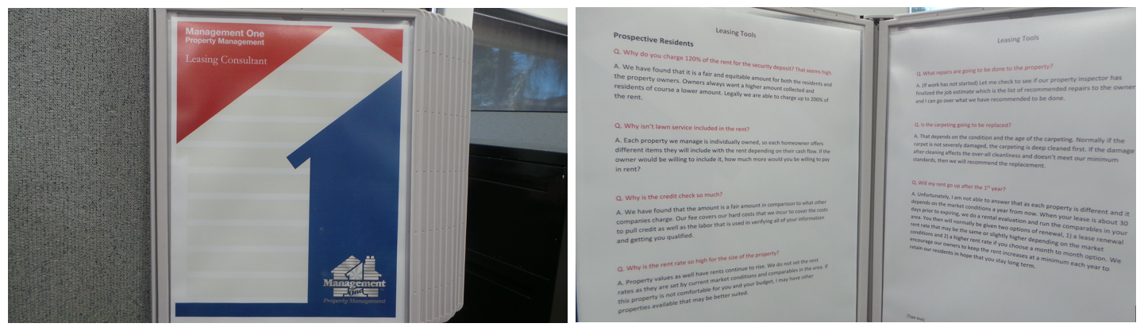

It is recommended that the following Frequently Asked Questions are printed and displayed in a Hanging Flip Chart in the Station or Cubical of the Leasing Consultant Division for Quick Reference.

This way the information is not hidden on the computer somewhere and it gives any new person the advantage they need for quick responses as well as providing superior customer service as they appear very knowledgeable from the very first day.

[Click Here to acquire your own "Wall Reference Organizer"](http://www.displays2go.com/P-24051/Wall-Mount-Reference-Rack-with-10-Binder-Pockets-with-2-Tabs)

Prospective Residents

Q. Why do you charge 120% of the rent for the security deposit? That seems high.

A. We have found that it is a fair and equitable amount for both the residents and the property owners. Owners always want a higher amount collected and residents of course a lower amount. Legally we are able to charge up to 200% of the rent.

Q. Why isn’t lawn service included in the rent?

A. Each property we manage is individually owned, so each homeowner offers different items they will include with the rent depending on their cash flow. If the owner would be willing to include it, how much more would you be willing to pay in rent?

Q. Why is the credit check so much?

A. We have found that the amount is a fair amount in comparison to what other companies charge. Our fee covers our hard costs that we incur to cover the costs to pull credit as well as the labor that is used in verifying all of your information and getting you qualified.

Q. Why is the rent rate so high for the size of the property?

A. Property values as well have rents continue to rise. We do not set the rent rates as they are set by current market conditions and comparables in the area. If this property is not comfortable for you and your budget, I may have other properties available that may be better suited.

Q. What repairs are going to be done to the property?

A. (If work has not started) Let me check to see if our property inspector has finalized the job estimate which is the list of recommended repairs to the owner and I can go over what we have recommended to be done.

Q. Is the carpeting going to be replaced?

A. That depends on the condition and the age of the carpeting. Normally if the carpet is not severely damaged, the carpeting is deep cleaned first. If the damage after cleaning affects the over-all cleanliness and doesn’t meet our minimum standards, then we will recommend the replacement.

Q. Will my rent go up after the 1st year?

A. Unfortunately, I am not able to answer that as each property is different and it depends on the market conditions a year from now. When your lease is about 30 days prior to expiring, we do a rental evaluation and run the comparables in your area. You then will normally be given two options of renewal, 1) a lease renewal rent rate that may be the same or slightly higher depending on the market conditions and 2) a higher rent rate if you choose a month to month option. We encourage our owners to keep the rent increases at a minimum each year to retain our residents in hope that you stay long term.

Q. We recently had our credit ran and have copies, can we just provide the copies we have to you? Why do we have to pay for another credit check?

A. Unfortunately, we have additional court searches & identity matches that are ran by our credit agency that may not appear on your credit report. It’s part of our qualifying process as we run independent reports to verify all credit reports ran are the same type.

B. If you are concerned about your credit and want to make sure you would qualify with us before spending the application fee; you are welcome to bring your copy into our office so we may review it. We should be able to get a general idea of looking at your credit if you should qualify providing that no other derogatory concerns come up in our extended search.

Q. How do you know if the owner is in good standing with their mortgage payments?

A. Before we put a property on the market for rent, we do a title search to verify there are no notices of delinquency filed on the property. We have no guarantee later if the homeowner stops making their payments months later, however as of now, all is showing current.

Q. Can we paint the walls a different color?

A. We are unable to authorize you to change the existing paint color due to liability reasons. For example: If someone gets hurt by falling off a ladder or if paint is spilled on the carpeting and damages are incurred. We do however require that the property is returned in the same condition when vacating (less normal wear and tear).

Application Process

Q. How long does it take to approve someone after an application has been submitted?

A. Typically it takes 24-48 hours to qualify an application once we receive it depending on how much information is provided to us at the time the application is turned in.

Q. Why can’t I be involved in the resident screening process?

A. We have found that in doing our extensive screening process and with following Fair Housing Laws, that our screening process is very thorough and timely to the prospective residents.

Q. Why can’t I get the residents information?

A. Per your agreement and well as the rental agreement, we need to have all communication through Management One. This way there is only one person managing the property and to avoid potential conflicts later.

Q. How does Management One insure the pets are kept outdoors?

A. There is no guarantee that pets will remain outdoors, however if we do our regular inspections to verify there are no signs of pets indoors. Also, if our vendors service the property, they also are our eyes to notify us if there are signs of pets indoors.

Q. How long should it take to get my property rented?

A. On average our properties take 30-45 days to rent depending on the availability date and the condition of the property.

Q. Can we raise the rent if we start getting a lot of activity?

A. If we are getting a lot of activity, that doesn’t warrant raising the rent, it means we are priced right to rent your property timely and to a qualified resident.

Q. Now that you have a qualified application, can you tell me about where the residents work and how much income they have?

A. Sure, they make at least 3 times the monthly rent, their debt ratio is X and they work at X.

Q. Is there any way that you can only rent my property to a certain race?

A. No, we are unable to discriminate against race, gender, children, etc.

Q. How many children do the residents have and what if I do not want children living in my home?

A. The residents have X children. We are unable to discriminate against children.

Q. Why do you take the first application that qualifies? Can’t we get a few and choose the best?

A. We qualify the first come first serve to stay in compliance with Fair Housing Laws.

Showings

Q. How can you be sure you can trust the person that checks out the keys to my property?

A. We have found over 25 years that by taking a copy of the prospect’s drivers license, obtaining a deposit for the key, limiting the prospect to 1 hour to have the keys checked out and by having them sign a document that gives them only the rights to view the property, we haven’t had any challenges with prospects damaging properties.

Q. Is there any way Management One can show my property at all times instead of allowing keys to be checked out?

A. Yes, we can personally show your property and if that is what you choose, you will limit the ability to show your property by at least 25%. We have found that prospects like to view the property on their own and we are also not limited on the time frame we are able to show your property.