Copyright © 2016 Management One Licensed Operating Systems, LLC. All rights reserved.

Management One Licensed Operating Systems

Knowledge Based Manual

FAQ- Frequently Asked Client Coordinator Questions and Answers

2016

Contents

FAQ- Frequently Asked Client Coordinator Questions and Answers 2

Quick Reference Flip Chart 2

Common Questions 3

FAQ- Frequently Asked Client Coordinator Questions and Answers

[Click Here to Download MS Word .docx file](http://app1.m1sys.com/PMOS/systemdocs/D%20-%20CC%20questions%20%20FLIP.docx)

Quick Reference Flip Chart

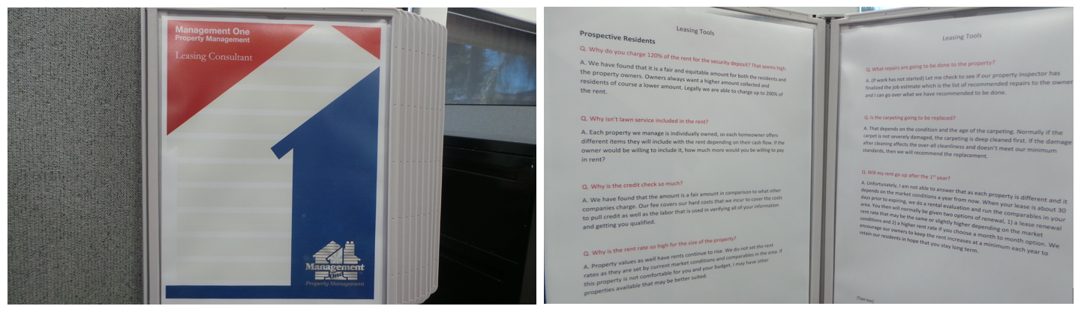

It is recommended that the following Frequently Asked Questions are printed and displayed in a Hanging Flip Chart in the Station or Cubical of the Leasing Consultant Division for Quick Reference.

This way the information is not hidden on the computer somewhere and it gives any new person the advantage they need for quick responses as well as providing superior customer service as they appear very knowledgeable from the very first day.

[Click Here to acquire your own "Wall Reference Organizer"](http://www.displays2go.com/P-24051/Wall-Mount-Reference-Rack-with-10-Binder-Pockets-with-2-Tabs)

Common Questions

Q. I need to speak with a manager, why are they not available?

A. Unfortunately my manager is out of the office at this time, is there anyone else that I may get to assist you? What is this concerning? If for any reason, X is unable to assist you, they will coordinate an appointment for you to speak with our manager.

Q. I’m going to be late on my rent, will I still get a 3Day Notice?

A. Yes, you will still receive a late notice posted on your door as well as mailed, however I have noted your file that you will be in by the [10th] with your rent.

Q. Has my rent been paid yet? It’s the [7th] of the month and I haven’t received the rent.

A. Let me check that for you, however normally rents are received by the 5th of the month and processed within 24 hours out to our owners. We ask that you wait to call in until the 10th of each month as there is a high volume of calls and our Accounting department is processing the rents and getting checks out. I can provide you your access to your owner portal for easy access in checking if your rent has been paid and processed each month.