Copyright © 2016 Management One Licensed Operating Systems, LLC. All rights reserved.

Management One Licensed Operating Systems

Knowledge Based Manual

FAQ- Frequently Asked Accounting Questions and Answers

2016

Contents

FAQ- Frequently Asked Accounting Questions and Answers 2

Quick Reference Flip Chart 2

Late Fees/Resident Owes 3

Rent Check 4

Management Contract Obligations 5

Legal Items 6

FAQ- Frequently Asked Accounting Questions and Answers

[Click Here to Download MS Word .docx file](http://app1.m1sys.com/PMOS/systemdocs/FAQ-%20Accounting%20Flip%20Chart.docx)

Quick Reference Flip Chart

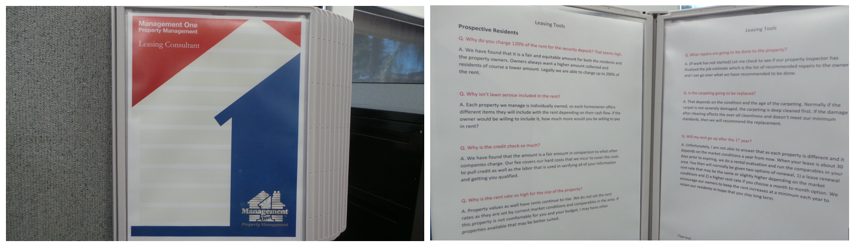

It is recommended that the following Frequently Asked Questions are printed and displayed in a Hanging Flip Chart in the Station or Cubical of the Accounting Division for Quick Reference.

This way the information is not hidden on the computer somewhere and it gives any new person the advantage they need for quick responses as well as providing superior customer service as they appear very knowledgeable from the very first day.

[Click Here to acquire your own "Wall Reference Organizer"](http://www.displays2go.com/P-24051/Wall-Mount-Reference-Rack-with-10-Binder-Pockets-with-2-Tabs)

Late Fees/Resident Owes

Q. Why haven’t the residents paid their late fees?

A. Unfortunately, the State requires us to collect the rent if the resident attempts to pay it within the 3-day period. We will be sending additional notices to the resident to pay the fees owed. We have found in most cases; the resident will make arrangements to get their late fees paid up before the end of the month.

Q. Why am I being charged for resident damage on a repair?

A. When the contractor goes to the property to complete the repair and determines it is the resident that should pay for it, we are still required to pay the contractor upon completion of the work. We do however immediately bill the resident for this repair and upon receipt of these funds from the resident, your account will be credited/reimbursed back.

Q. Why do I have to owe late fees when I’m only one day late?

A. Actually, your rent is due on the 1st and we give you a grace period through the 5th. Just like a car payment, unfortunately if you are 1 day late, fees are assessed.

Rent Check

Q. How quickly will I receive my first rent check?

A. Typically we process your check within 24-48 hours of the new resident’s move in date.

Q. What is normally deducted from the first rent?

A. We deduct our management fee and lease up fee from the first month’s rent.

Q. Why is there a $400 retain on my account when the resident already moved in?

A. We retain the $400 to cover any possible closing utility bills, lawn service bills, etc. and release the retain on the 2nd month once we have confirmed all bills have been paid.

Q. How long is the eviction process?

A. The eviction process typically takes 45-60 days depending if the resident contests the eviction or not. Let me send you an eviction map that will give you an estimated timeline of the eviction process.

Management Contract Obligations

Q. If I need to move back into my home prior to the expiration of my contract, why do I have to pay the remaining contract amount?

A. All of our contracts are for one year terms. In order for us to provide the services that we do, we must forecast accounts a year in advance.

Q. If my property has not rented after one month and I want to cancel my contract, why am I still charged for the contract when you really have not done much?

A. Unfortunately, all contracts are for one year and we have extended extensive labor on your account thus far. Our new accounts division, accounting division, leasing division and maintenance division have all been involved on your property.

Q. Why does Management One keep the security deposit when it’s really the owner’s deposit?

A. It’s actually the resident’s security deposit. We have found over several surveys that residents rent through management companies for the peace of mind that their security deposit is in a trust account as many of them have had bad experiences in the past where private parties have taken their security deposits.

I want to sell my property; how does it work?

I want to move back into my property, what do I do?

Legal Items

Q. The resident didn’t vacate per the 30/60-day notice that was given, what action do I take?

A. First, you will need to verify if the resident is still in possession.

* Contact the resident to verify when they will be vacating/turning in keys – if not within 24-48 hours you may be forced to file an eviction.
* Do NOT serve any additional notices to the resident as it may negate the original notice to vacate.
* If they haven’t paid rent, only serve a 3 day for the prorated number of days through the scheduled vacate date. Do not serve a 3 Day Pay or Quit passed the scheduled vacate date as this will delay the eviction process.
* If the resident fails to vacate, contact the owner and advise legal action will be started and file the eviction paperwork on the notice to vacate.