# **Emergency Guide__________________________________________**

Your Company Name has provided this handy guide so you can see exactly where to re-set or turn things off in case of emergencies.

1. We ask that you follow the procedure outlined first.
2. 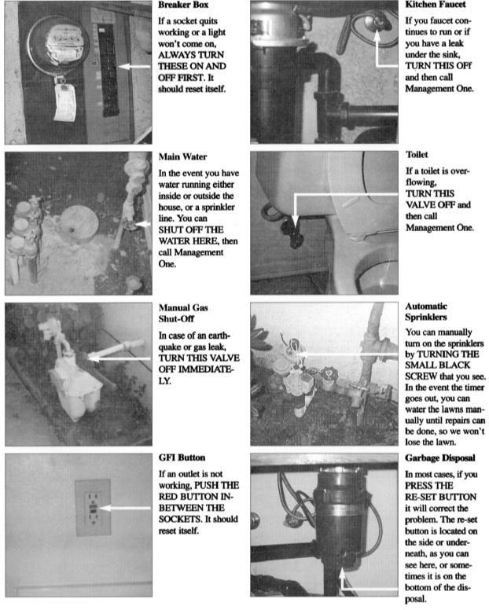If, after you have followed the procedure, it still does not take care of the problem, contact our office if during business, or if after hours, please call our emergency line

**000-000-0000**. (Please note a **$****50 fine** will be assessed for calls that are not true Emergency calls).